**NeptuneDigital Demo Introduction Document**

|  |  |  |  |
| --- | --- | --- | --- |
| Author： | MinHong Liang | Date： | 2022/07/20 |

1. Getting Stated – Environment 2

1.1 Browsers and plug-ins 2

1.1.1 Install Chrome browser 2

1.1.2 Install metamask 2

1.1.3 MetaMask create /import account 3

1.2 BSN account application and registration 4

1.3 Establish chain account and Wuhan chain project 5

1.3.1 Login to the BSN management background 5

1.3.2 Establish chain account 6

1.3.3 Recharge the chain account 7

1.3.4 Establish a project based on Wuhan Chain 9

1.4 Add Wuhan chain network to MetaMask 9

2. Neptune Digital DEMO Demonstration 10

2.1 Download DEMO, install dependency packages and start demo 10

2.2 Test MetaMask login 11

2.3 Test Online IDE 12

2.3.1 Uploading/writing smart contracts 14

2.3.2 Compile the contract 15

2.3.3 Deploying the smart contract 16

2.3.4 Calling the contract interface 19

2.4 View Wuhan Chain Blockchain Browser 21

# 1. Getting Stated – Environment

## 1.1 Browsers and plug-ins

### 1.1.1 Install Chrome browser

download chrome browser and install.

### 1.1.2 Install metamask

Note: You need to ensure that the local network can access google related websites.

(1) Enter chrome://extensions/ in the browser address and click the button in the upper left corner.

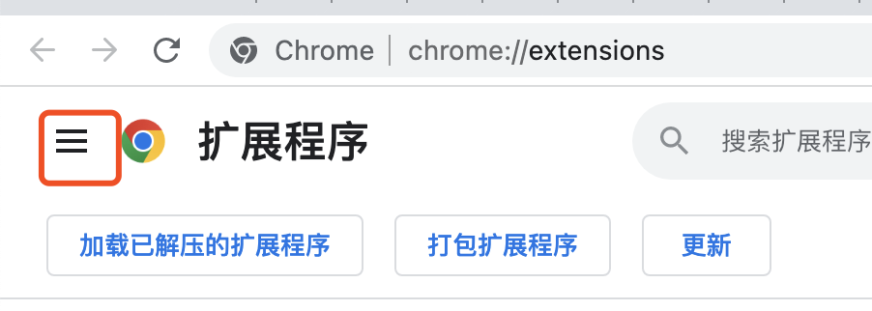

(2) Click "Open Chrome Web Store" in the lower left corner.

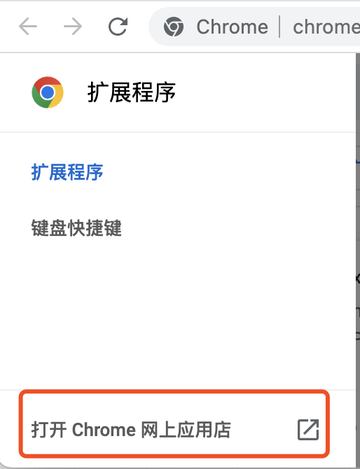

Type “MetaMask " in the search bar and press Enter.

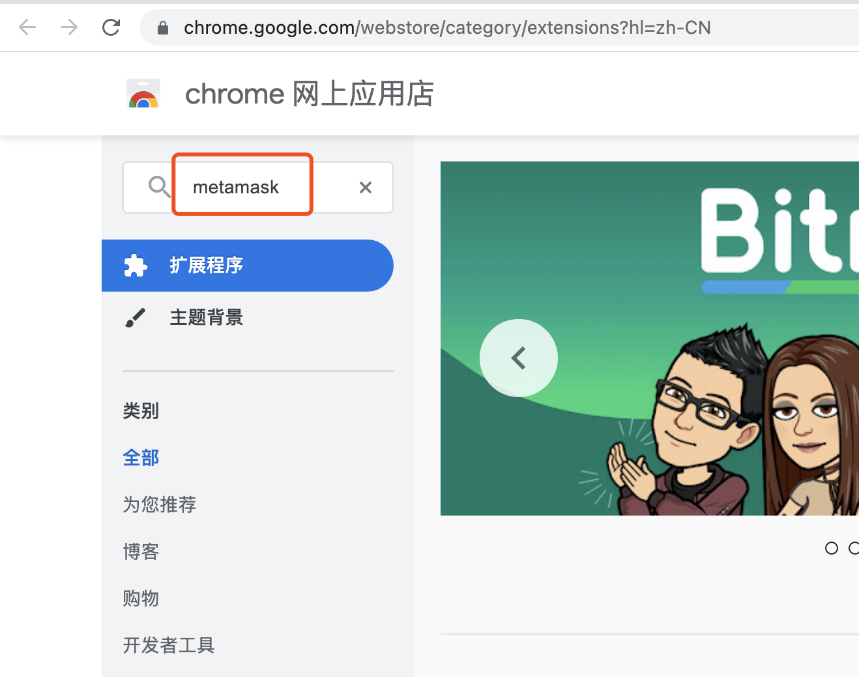

(4) Click on the MetaMask plugin that appears, and choose to install the plugin.

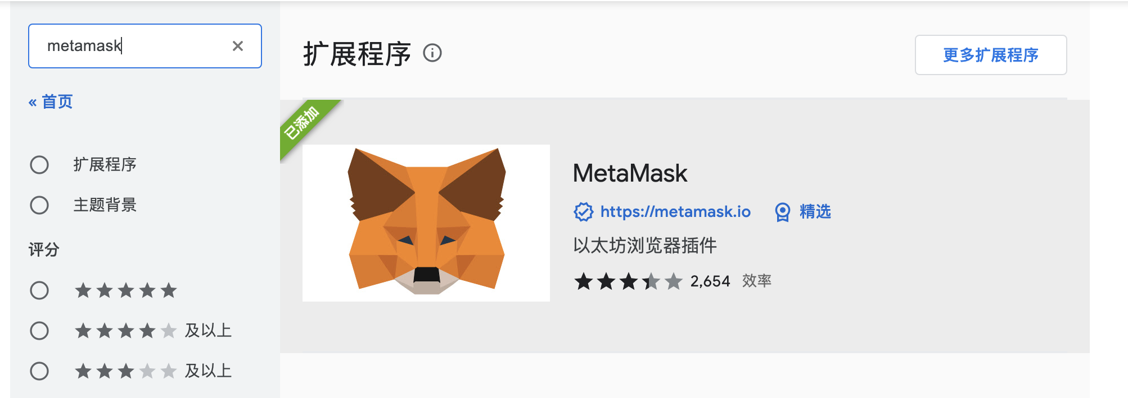

MetaMask plugin of the little fox icon will appear in the chrome browser. If it does not appear, you can click the extension application management icon to manually pin the MetaMask icon to the extension bar.

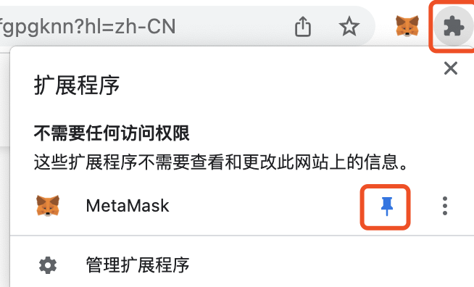

### 1.1.3 MetaMask create /import account

If you had an account with MetaMask before, you can choose to import the account operation. You can create a new account if you don't have any accounts. Each person can create multiple accounts. Click the MetaMask icon, click the icon in the upper right corner, click “Create Account”, and enter the account name to create a new account.

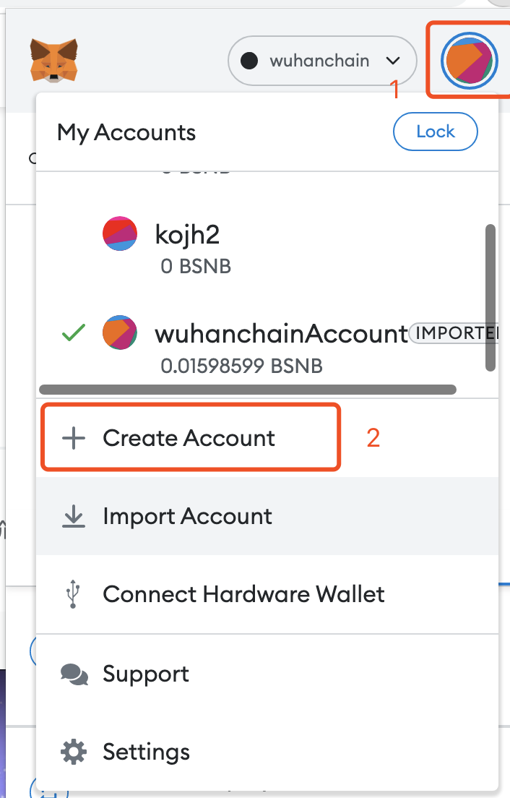

## 1.2 BSN account application and registration

Open the network address in the browser: www.bsnbase.com (Note: the IP of the local network must be in China, otherwise the website cannot be opened). Click the [Register] button on the login page to enter the registration application page:

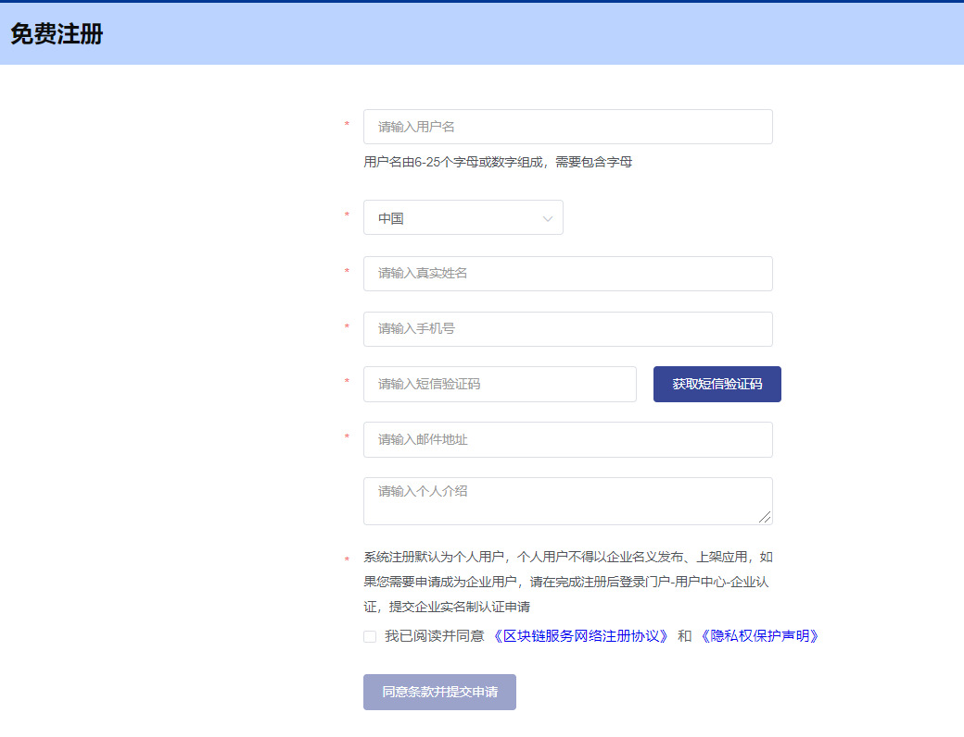

Fill in the registration application information according to the prompts on the page and submit it. The registration application user is registered as [Individual User] by default. If an enterprise invoice needs to be issued for the cost of publishing the application on BSN, it is recommended to apply to become a [Enterprise User]. certification application;

After the registration application is submitted, you will receive an activation email sent by the system, and the user can click the activation link in the activation email to set the login password for activation; after the account is activated, you can log in to the system for use.

Apply for enterprise real-name authentication: After logging in to the portal, go to User Center - Enterprise Authentication, and submit an application for enterprise real-name authentication. After submission, the operator will review it;

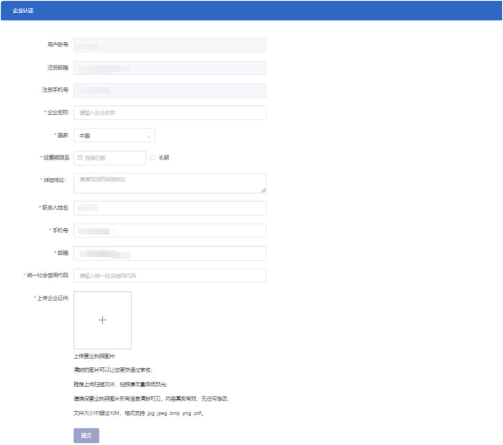

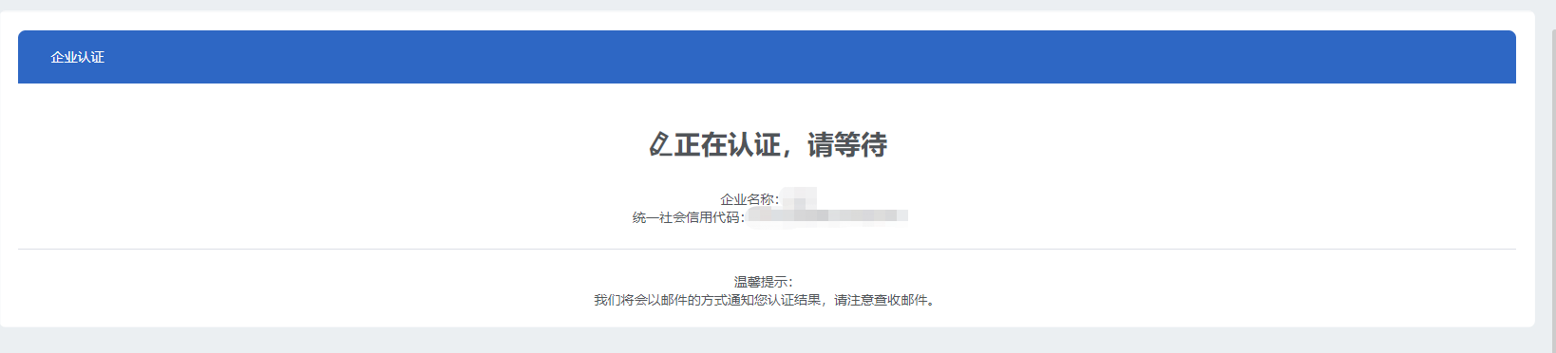

After the review is passed, the email and mobile phone will receive a notification that the company's real-name authentication has passed the review.

## 1.3 Establish chain account and Wuhan chain project

### 1.3.1 Login to the BSN management background

After successfully registering a BSN account, open <https://bsnbase.com/>and enter the username, password, and verification code to log in to the BSN management background.

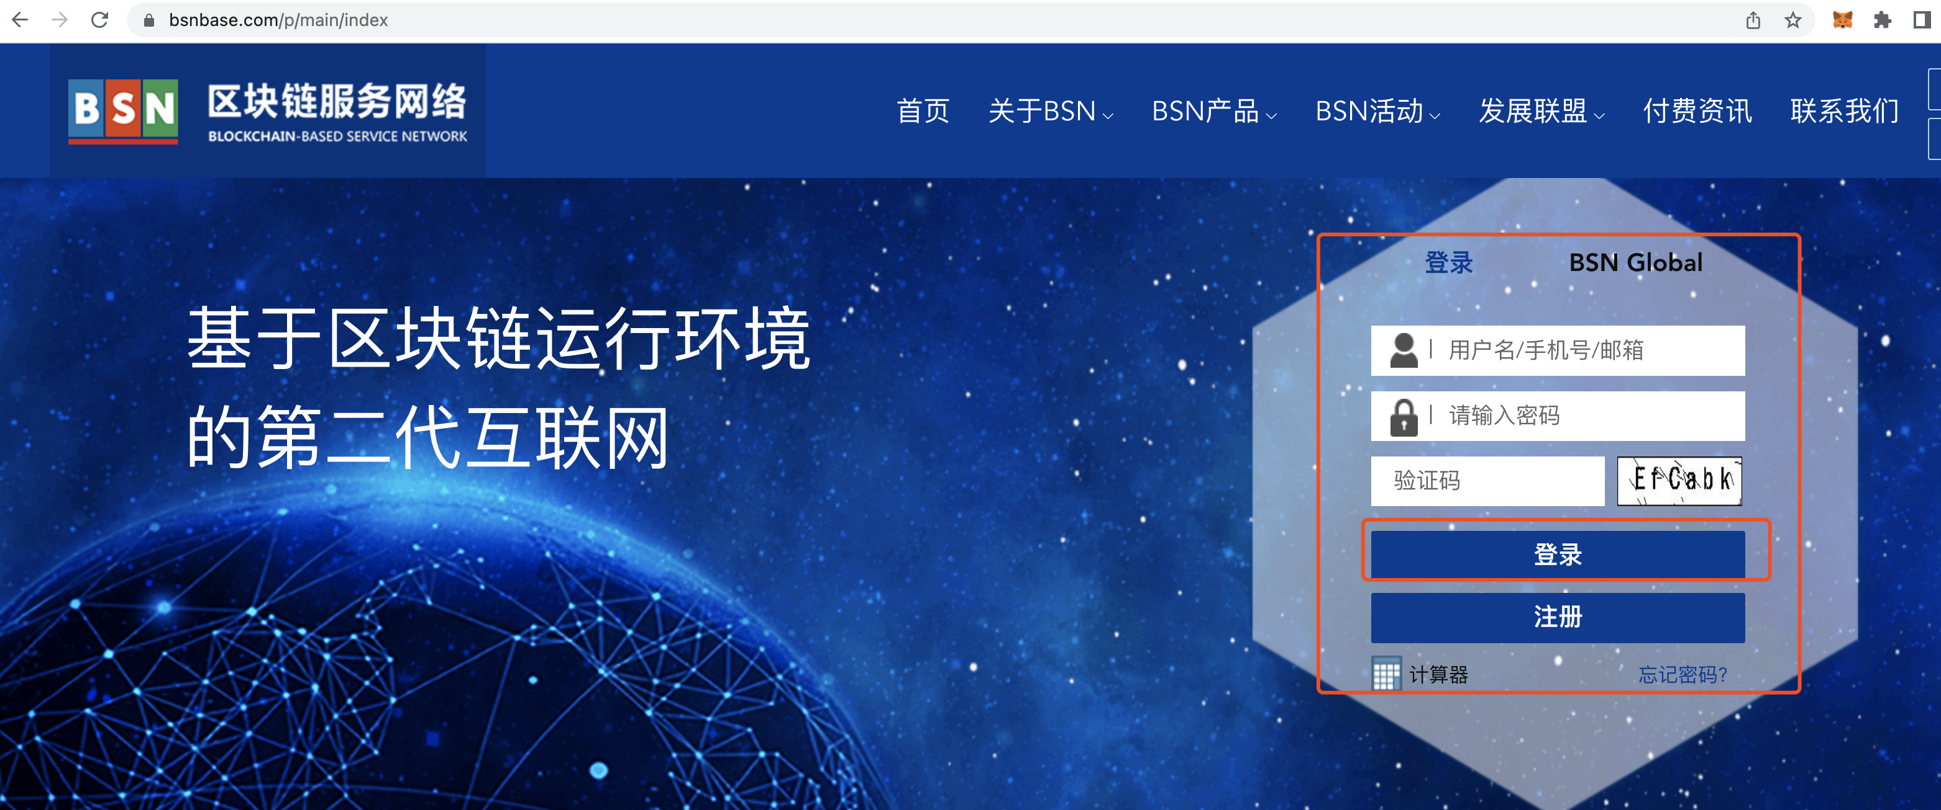

### 1.3.2 Establish chain account

Open [Open Alliance Chain] - > [Chain Account Management] - > [Create Chain Account] on the left menu bar.

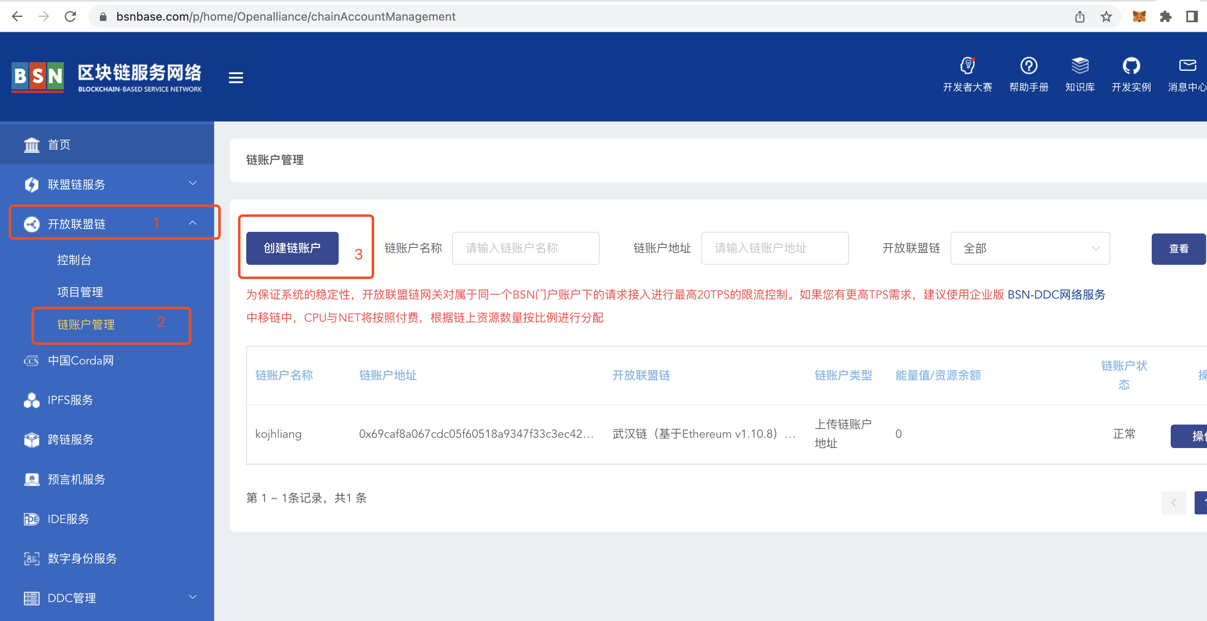

Enter the desired account name in the "Chain Account Name" field, select "Wuhan Chain" in "Open Alliance Chain", and select "Upload Account Address" for the account type.

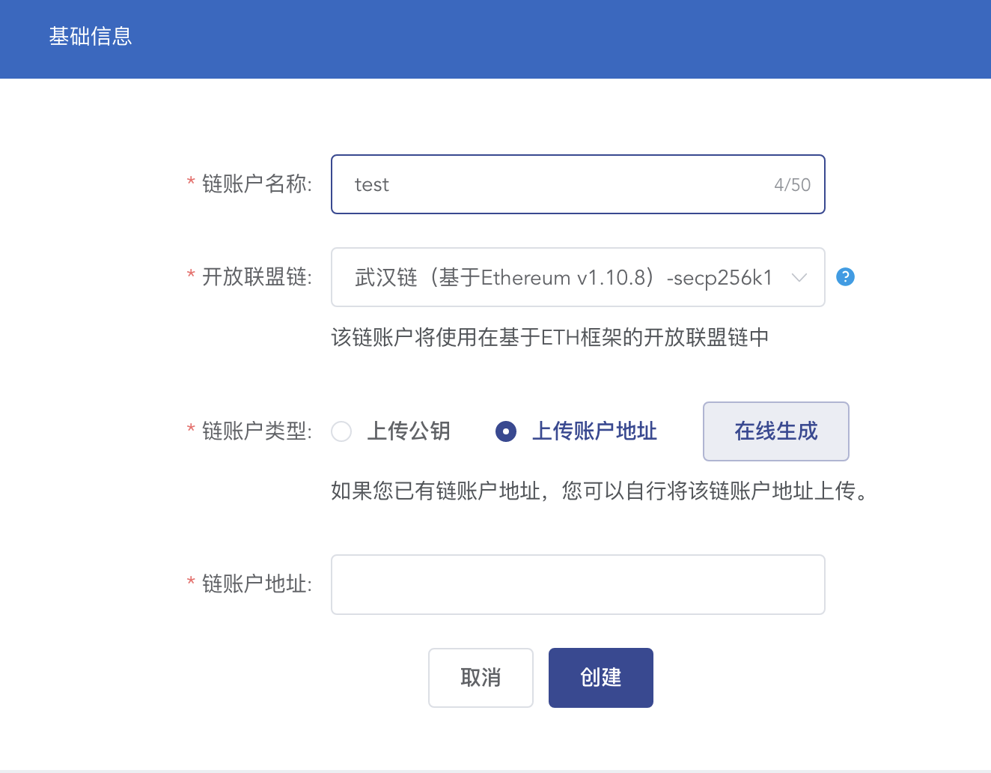

MetaMask wallet in the "chain account address", you can directly open MetaMask and click the middle account address to automatically copy the account address information, then paste it into the "chain account address" column, and finally click create.

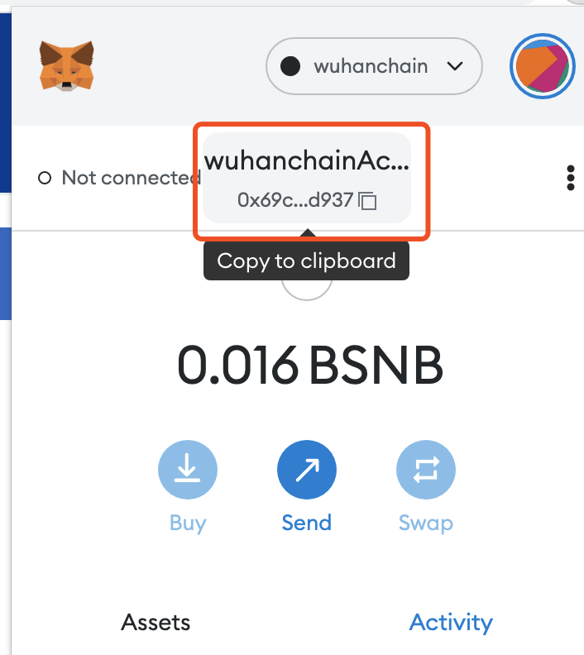

### 1.3.3 Recharge the chain account

Deploying smart contracts and sending transactions to Wuhan Chain requires a certain amount of resources (energy value) in the chain account. In order to deploy smart contracts and invoke smart contract operations normally in subsequent demo examples, it is necessary to recharge the chain account with a certain amount first. Generally, a recharge of 5 yuan can support 10-20 transaction operations (the value of the energy value is subject to the official website price).

Select a chain account address in the [Chain Account Management] module, and click "Assign Energy Value" in the "Operation" button.

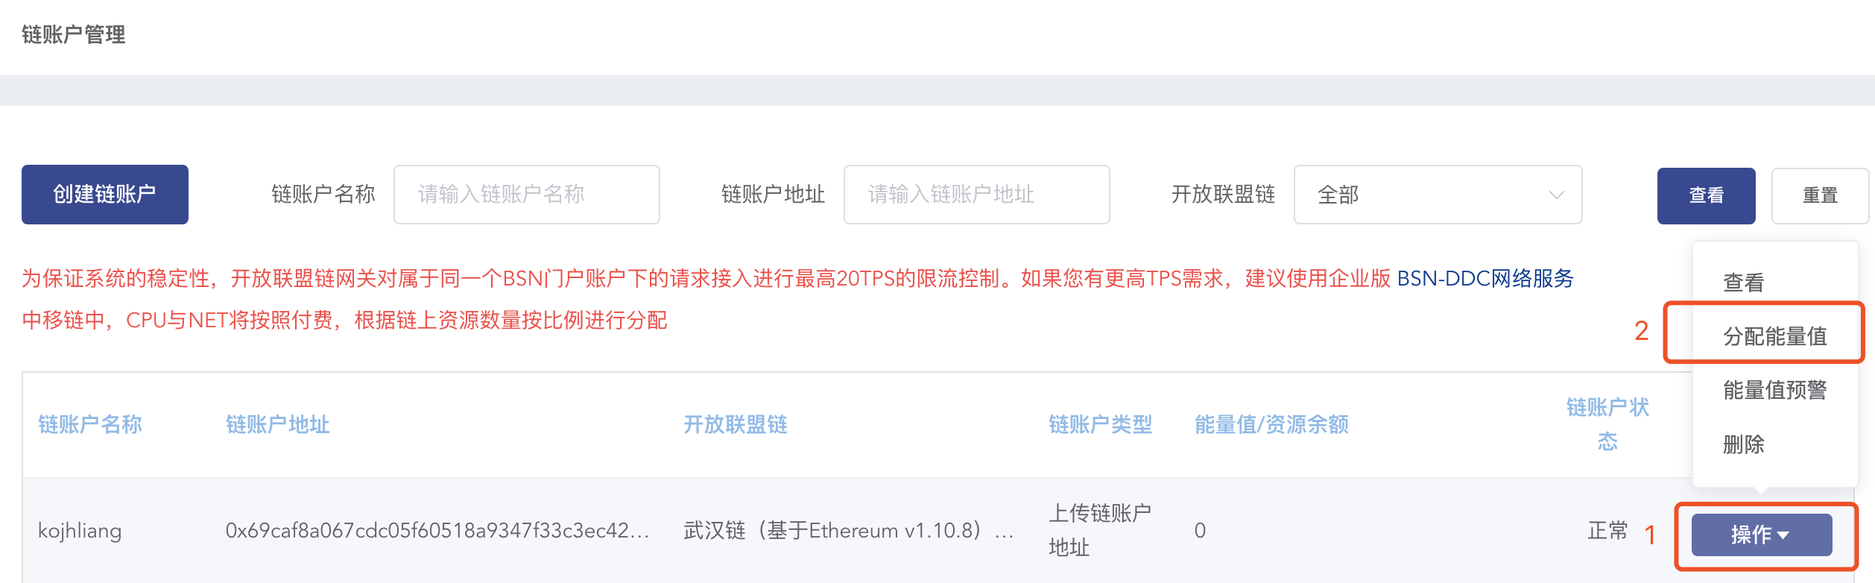

Click the "Recharge" button, after the recharge is complete, select the amount allocated to this chain account, and click "Confirm allocation". Note: After recharging, there will be a certain delay in updating the account balance, please be patient.

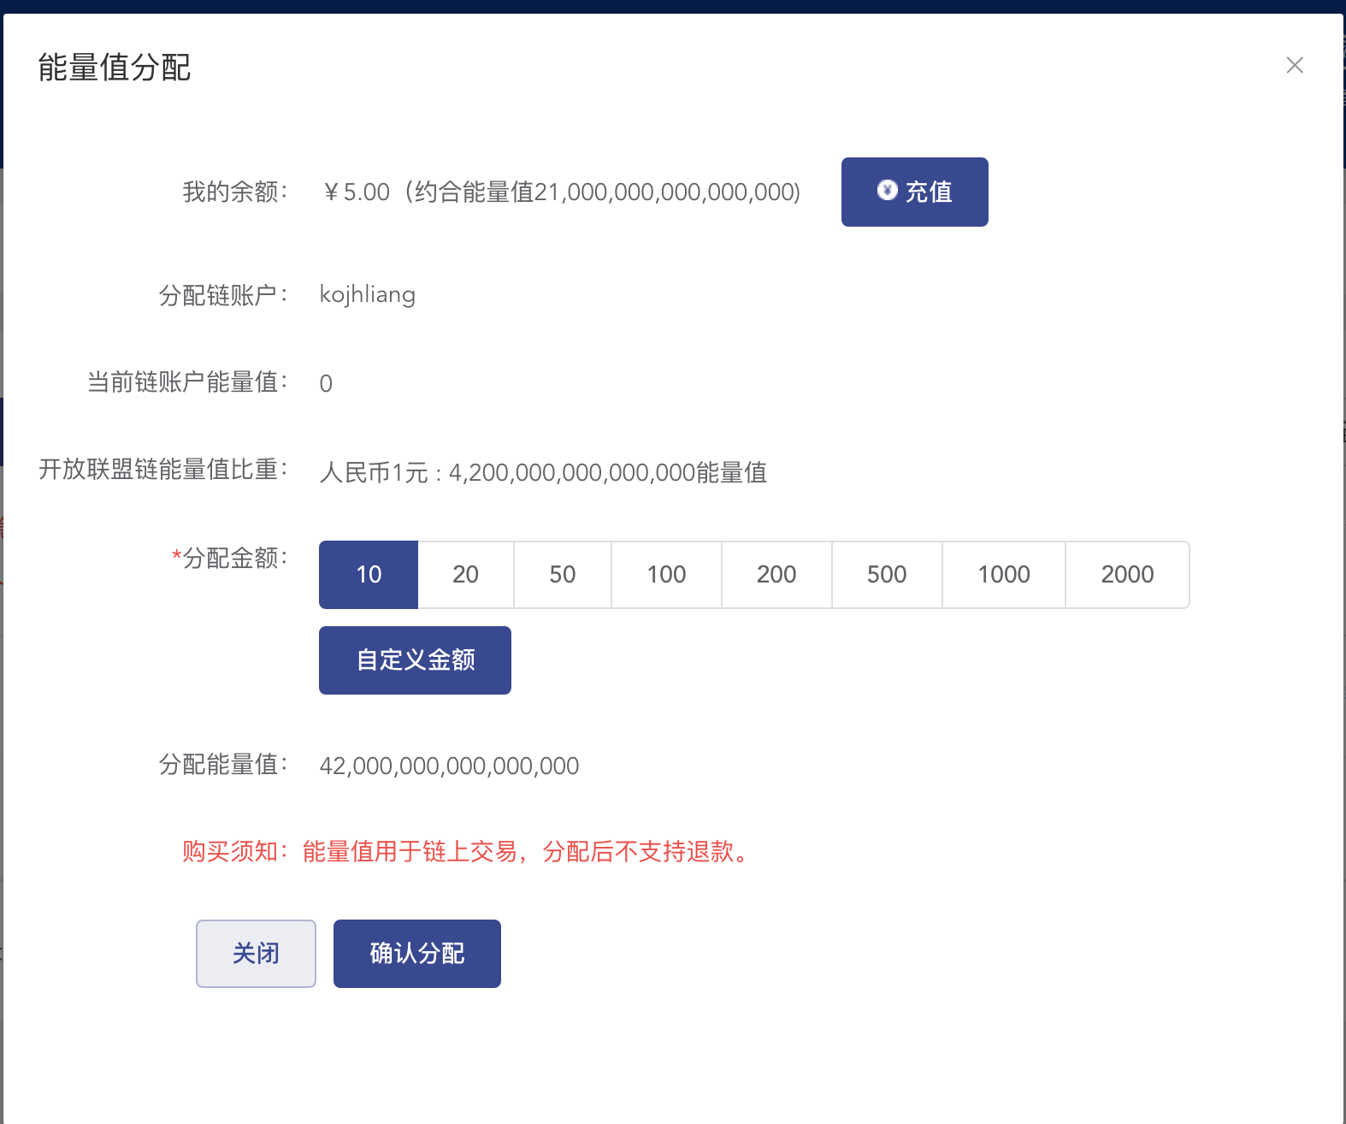

### 1.3.4 Establish a project based on Wuhan Chain

Open [Open Alliance Chain] - > [Project Management] - > [Create Project] on the left menu bar,

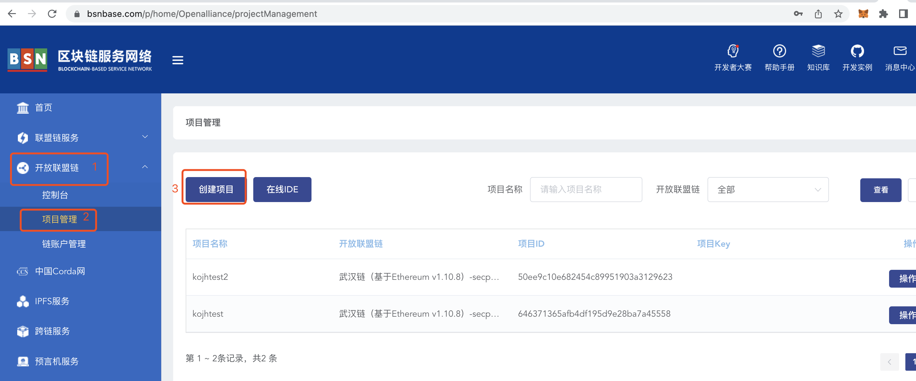

Enter the project name, select the Open Alliance Chain as Wuhan Chain, and click Finish to create.

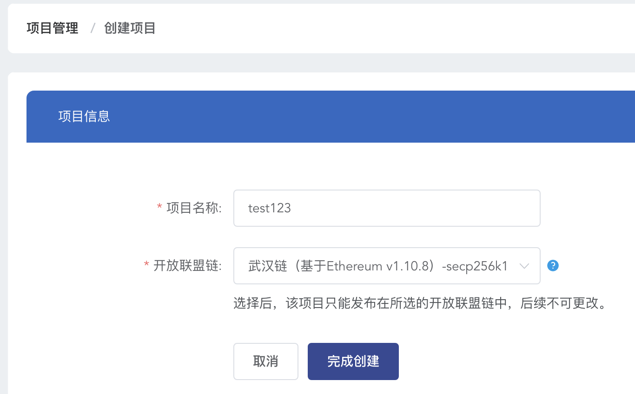

Return to the project management page, copy the project ID information, and then connect the MetaMask wallet to the Wuhan chain network, and use the project ID information to splicing out a complete RPC URL.

## 1.4 Add Wuhan chain network to MetaMask

Note: Before adding the Wuhan Chain network to MetaMask , you must complete the creation of the chain account and the project based on the Wuhan Chain.

Click the network drop-down box in the middle of the MetaMask interface.Click "Add Network" .Complete the information as follow:

(1) Fill in " wuhanchain " for networkName

(2) Fill in "5555" for chainID

(3) Fill in " http://explorer.ope.bsnbase.com/ " for Block Explorer

(4) Fill in " https://opbningxia.bsngate.com:18602/api/your-project-id/rpc " for New RPC

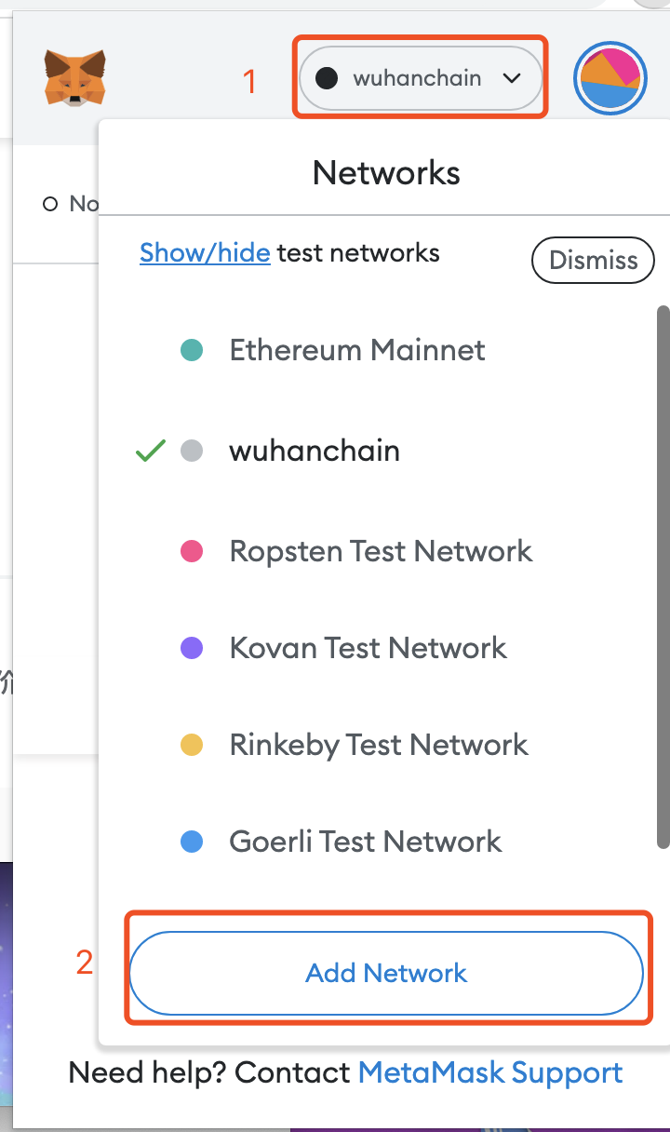

(5) Fill in “BSNB”for Currency Symbol

Note: ChainID and New RPC URL must be filled in correctly, and the rest of the attributes can be customized by the user.

# 2. Neptune Digital DEMO Demonstration

Neptune Digital Company is committed to the promotion and publicity of Wuhan Chain, providing domestic developers and enterprise customers with convenient and easy-to-use open alliance chain Ethereum services and related solutions.

## 2.1 Download DEMO, install dependency packages and start demo

Neptune Digital DEMO project, this project mainly shows how to use nodejs + react to link the Wuhan chain network of MetaMask to obtain account address and balance information.

Download the demo project at neptunedigtal official website, enter the demo directory, and type the following command:

yarn install #Install related dependencies

cd packages/backend && yarn install #Install backend project dependencies

cd ../frontend && yarn install #Install front-end project dependencies

cd ../.. #return to home directory

yarn lint – fix && yarn start #Start front-end and back-end projects at the same time

The startup address of the back-end project is localhost:8000, and the startup address of the front-end project is localhost:3 000.

Note: To run this project, you need to install nodejs , yarn and other tools in advance.

## 2.2 Test MetaMask login

Enter localhost : 3000 in the browser and open the page.

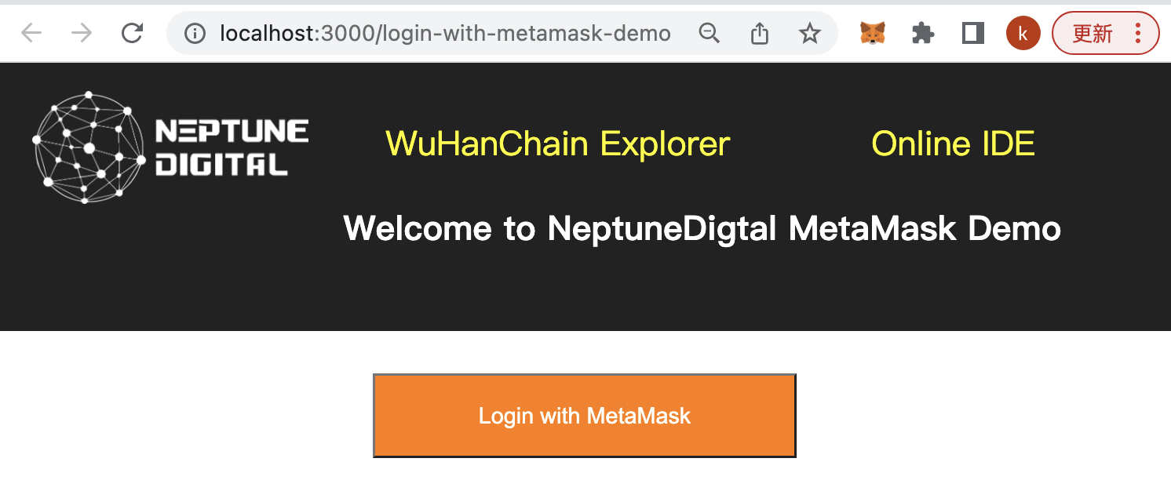

Click "Login with MetaMask" in the middle of the page, and MetaMask will receive a transaction signature message.

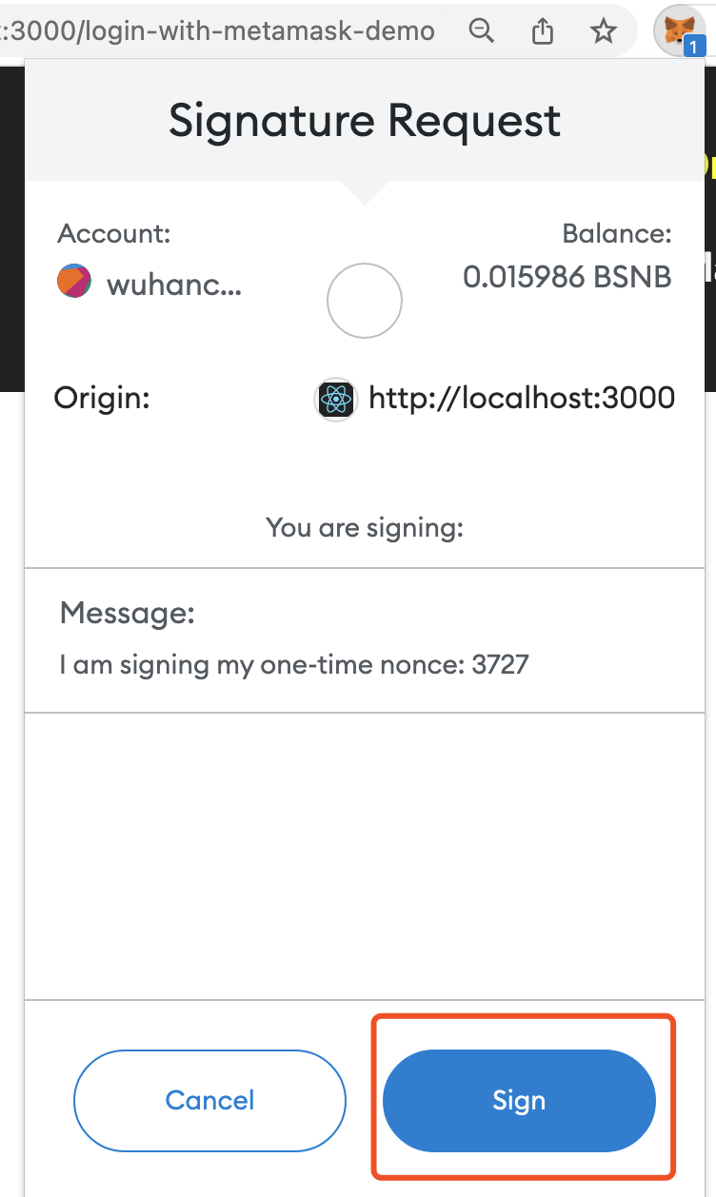

Click the MetaMask wallet icon and sign it, the account address and energy value balance will be displayed.

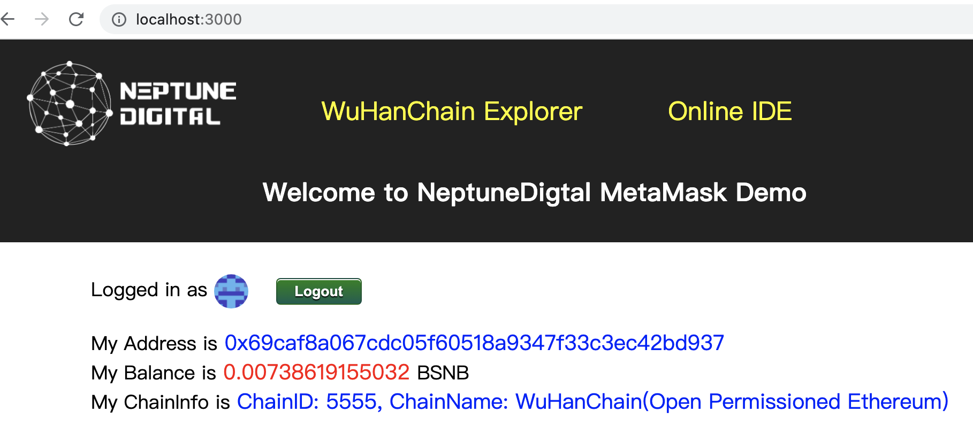

## 2.3 Test Online IDE

Click "Online" on the DEMO page IDE” to enter the online IDE editor page.If this is your first entry, you need to login to your BSN account and authorize it.

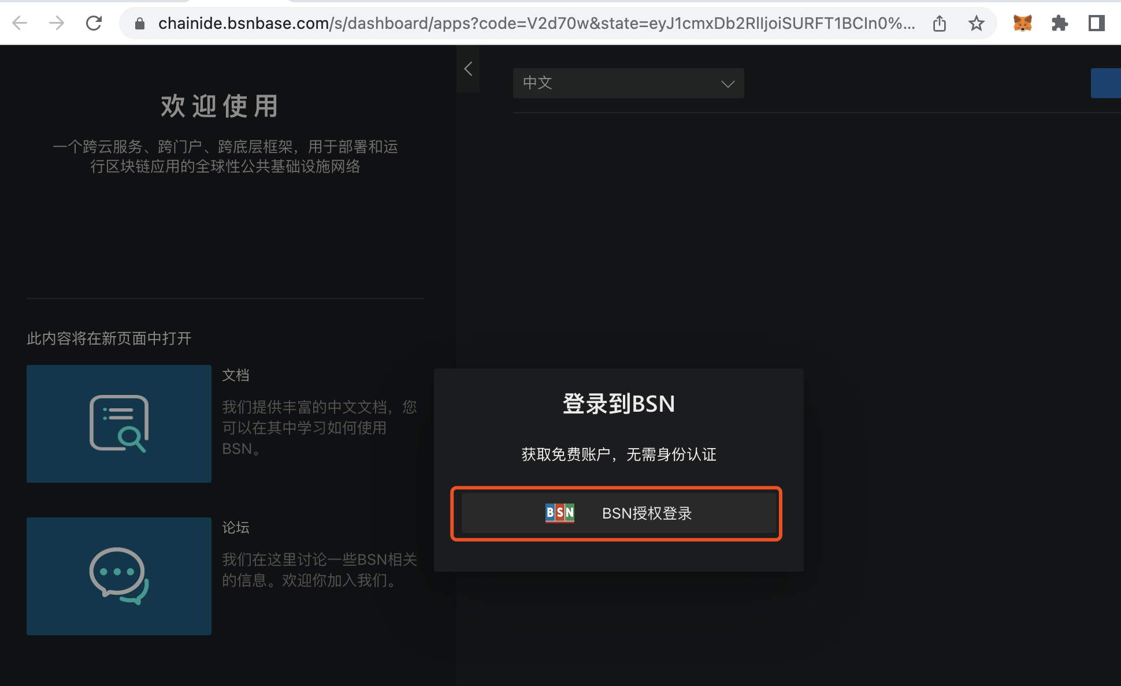

Enter the BSN account name and password registered in step 1.2. Click Login, and then click "Agree to Authorize".

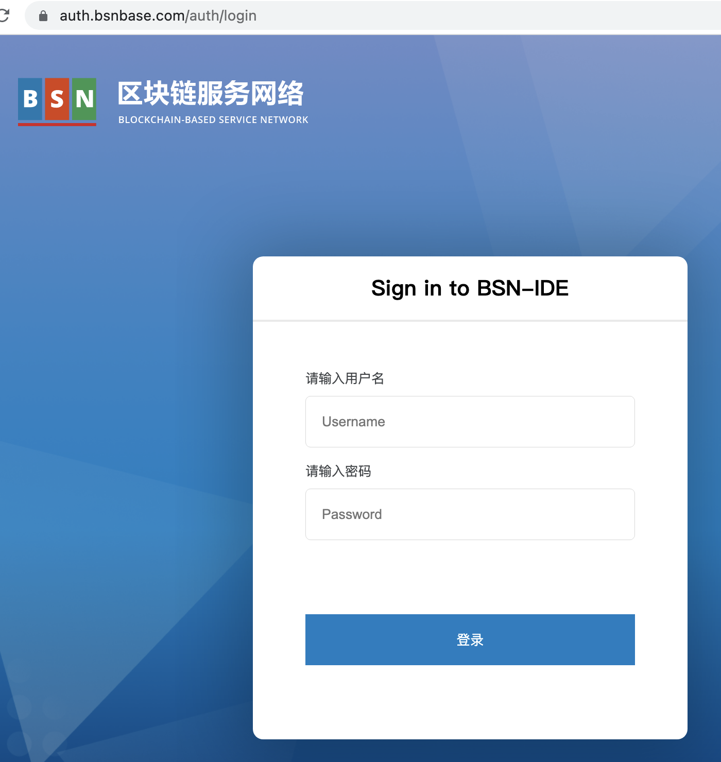

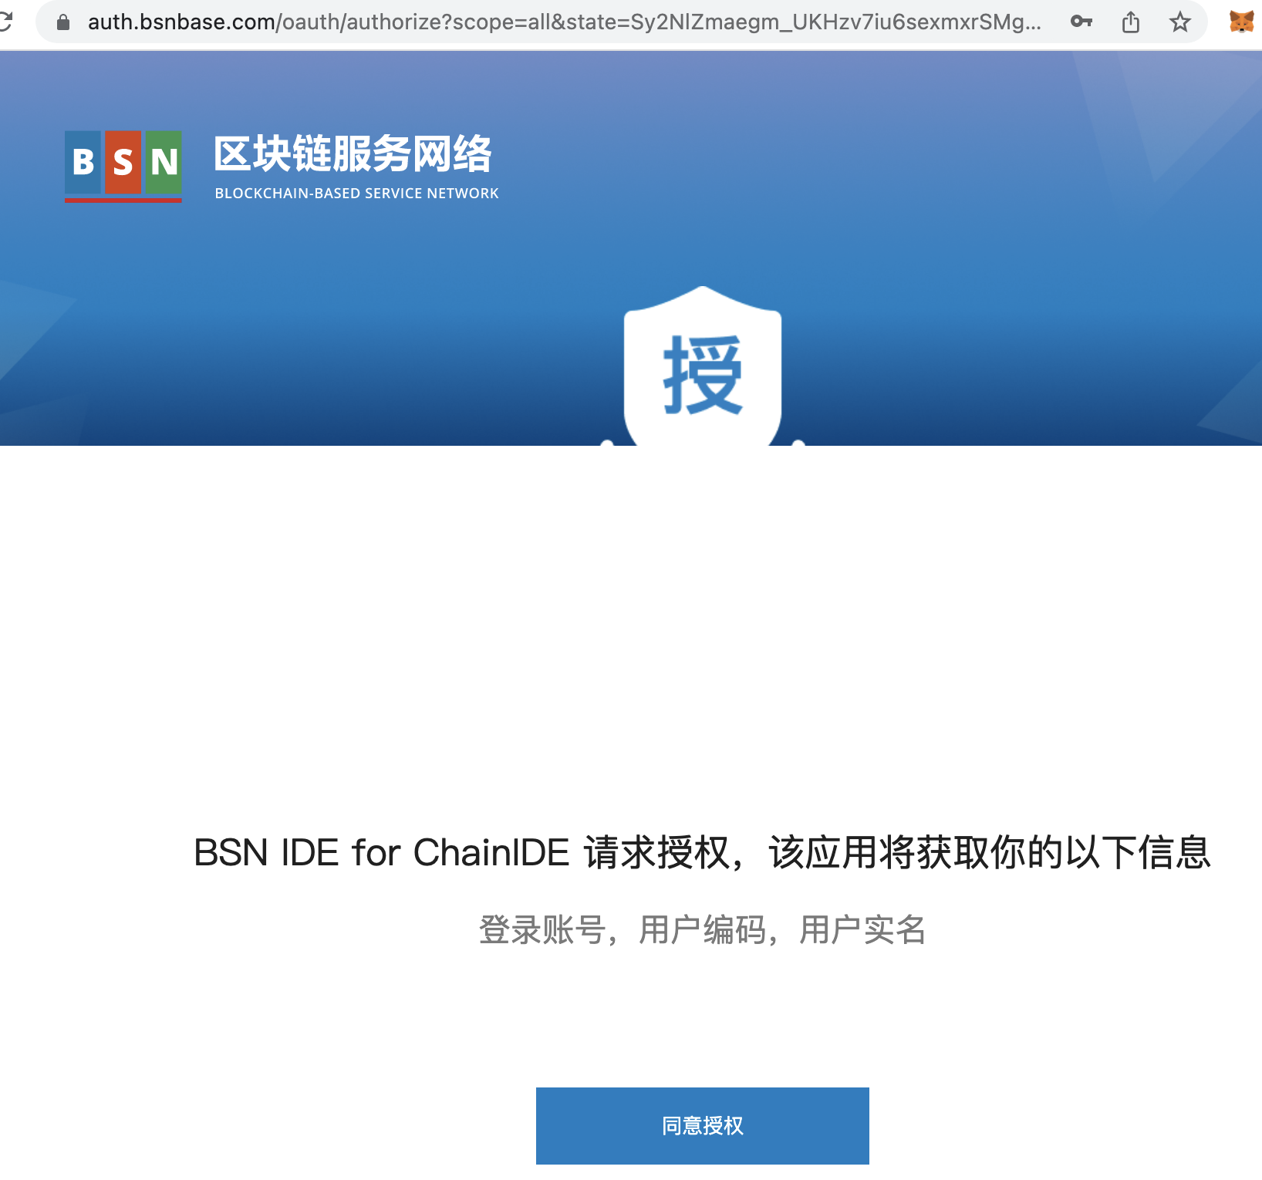

In the main interface of the online IDE, select a previously established project based on Wuhan Chain and click "Open". If you have not established a project before, you can also click "New Project" to create a project based on Wuhan Chain.

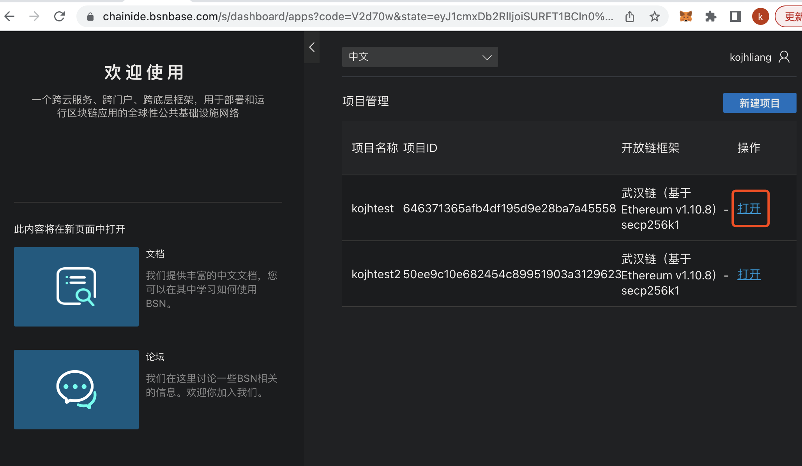

### 2.3.1 Uploading/writing smart contracts

After opening the project, click "New Contract Package".

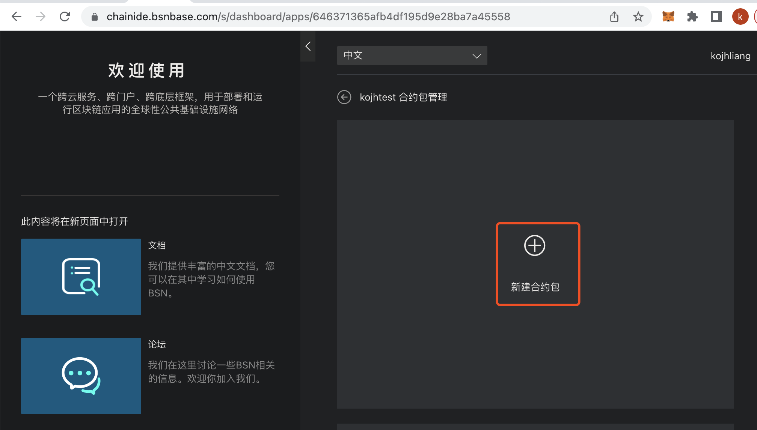

If you already have a written contract, you can click "Upload Contract Package", or you can create a contract based on an existing contract template. Here we choose to create a "Storage" contract.

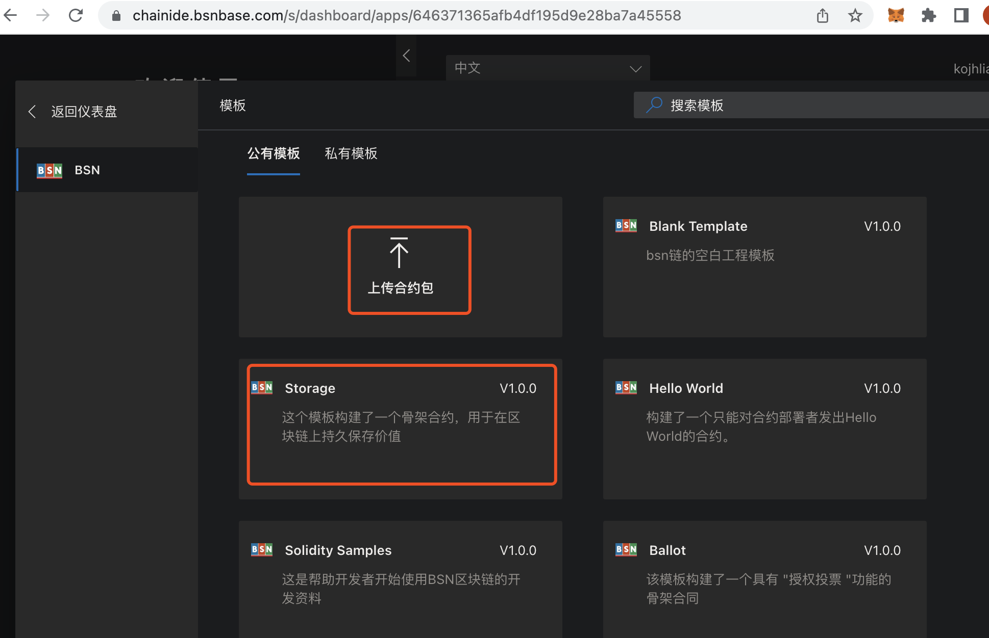

After the contract is successfully created, enter the IDE file editing main interface, click the file under "Resource Manager", and you can see the content of the corresponding contract file.

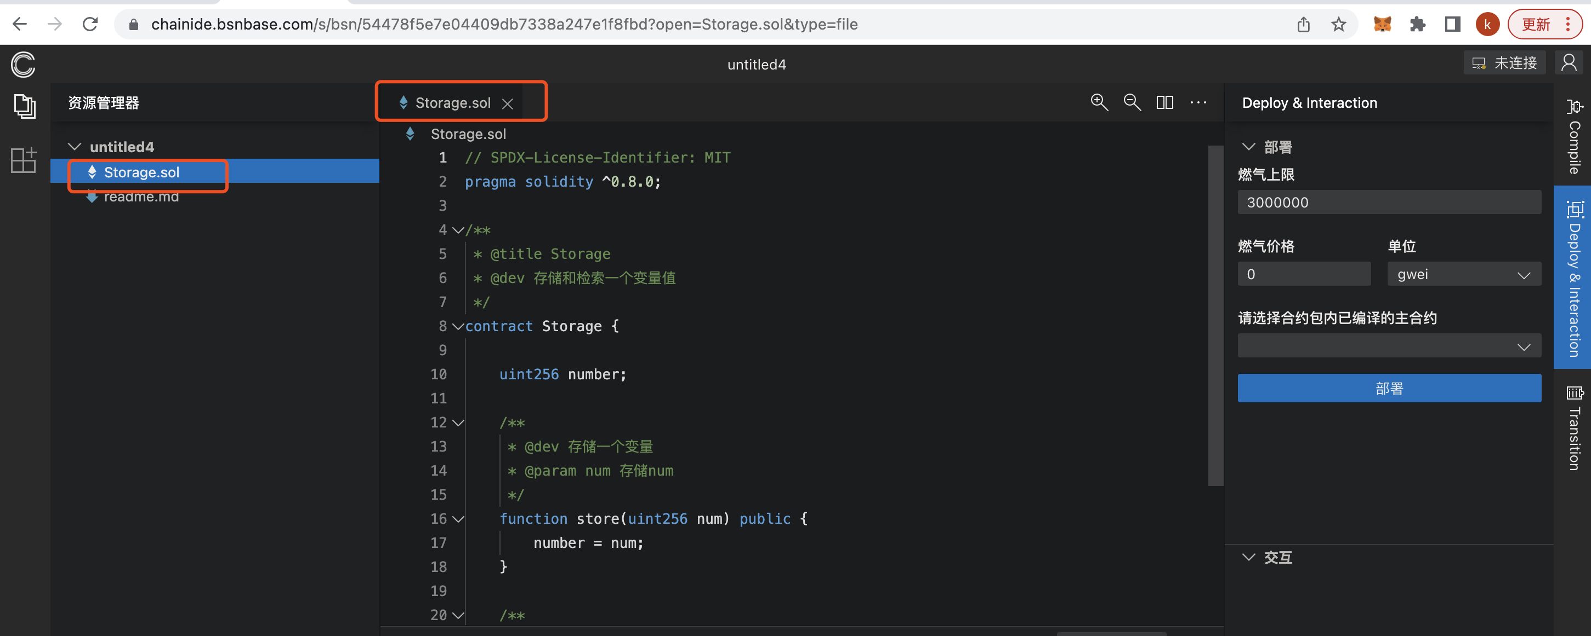

### 2.3.2 Compile the contract

Click "Compile" in the right sidebar, then click the "Compile Storage .sol " button. The output terminal at the bottom of the page will display information about the compilation.

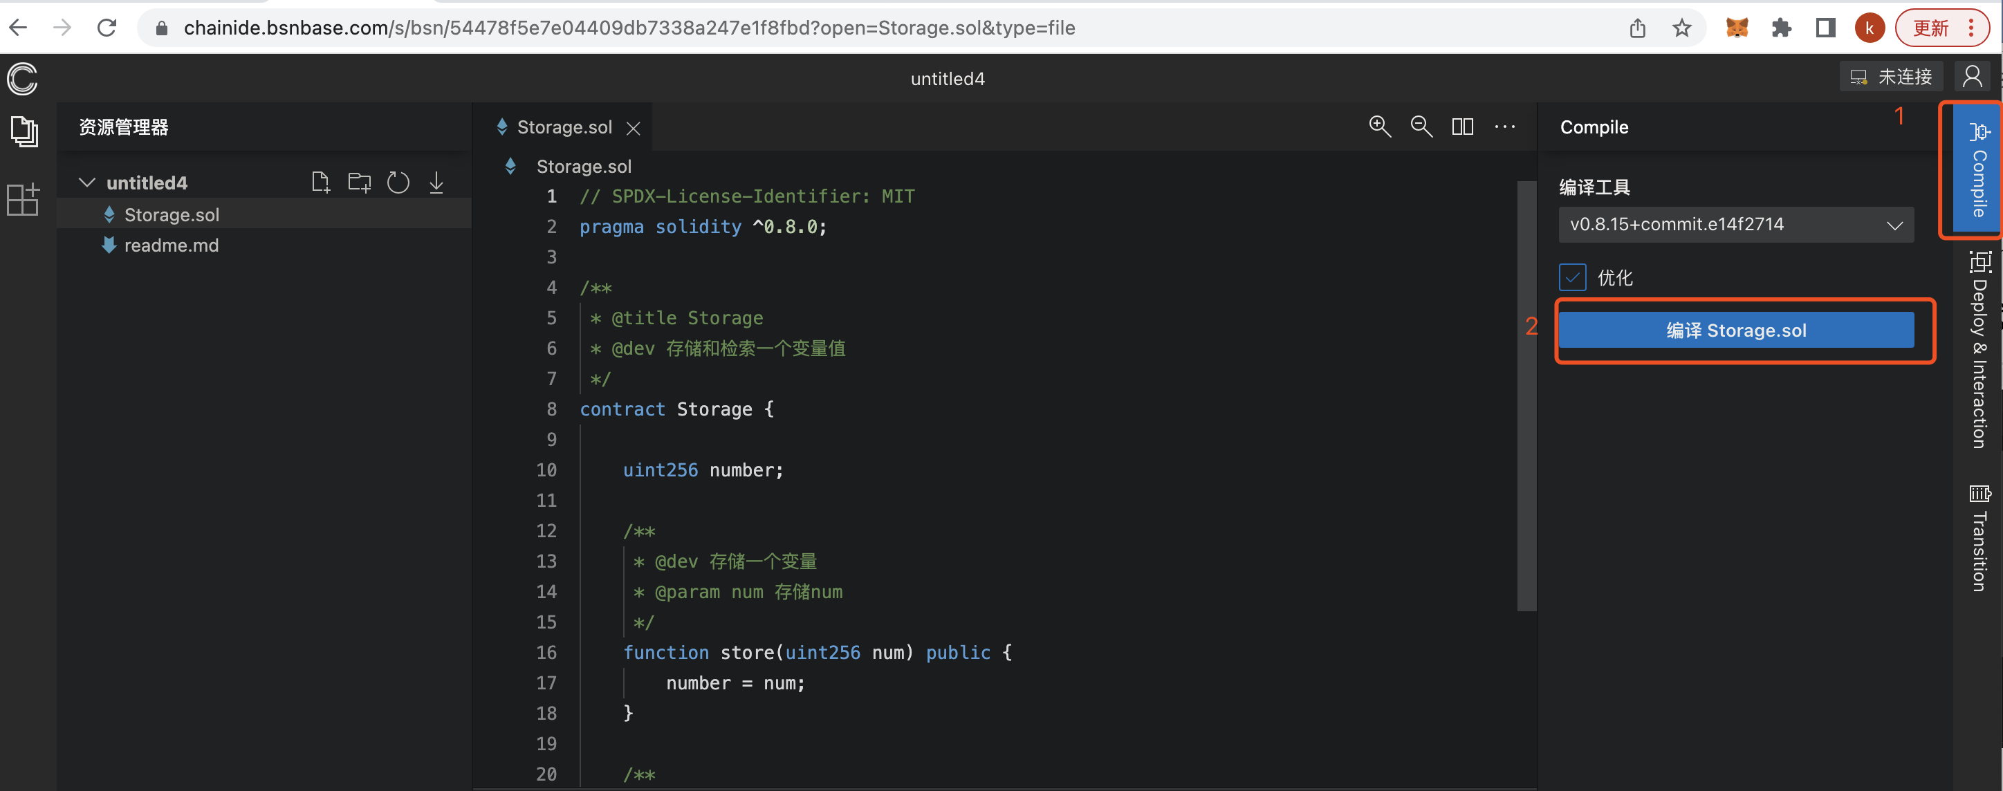

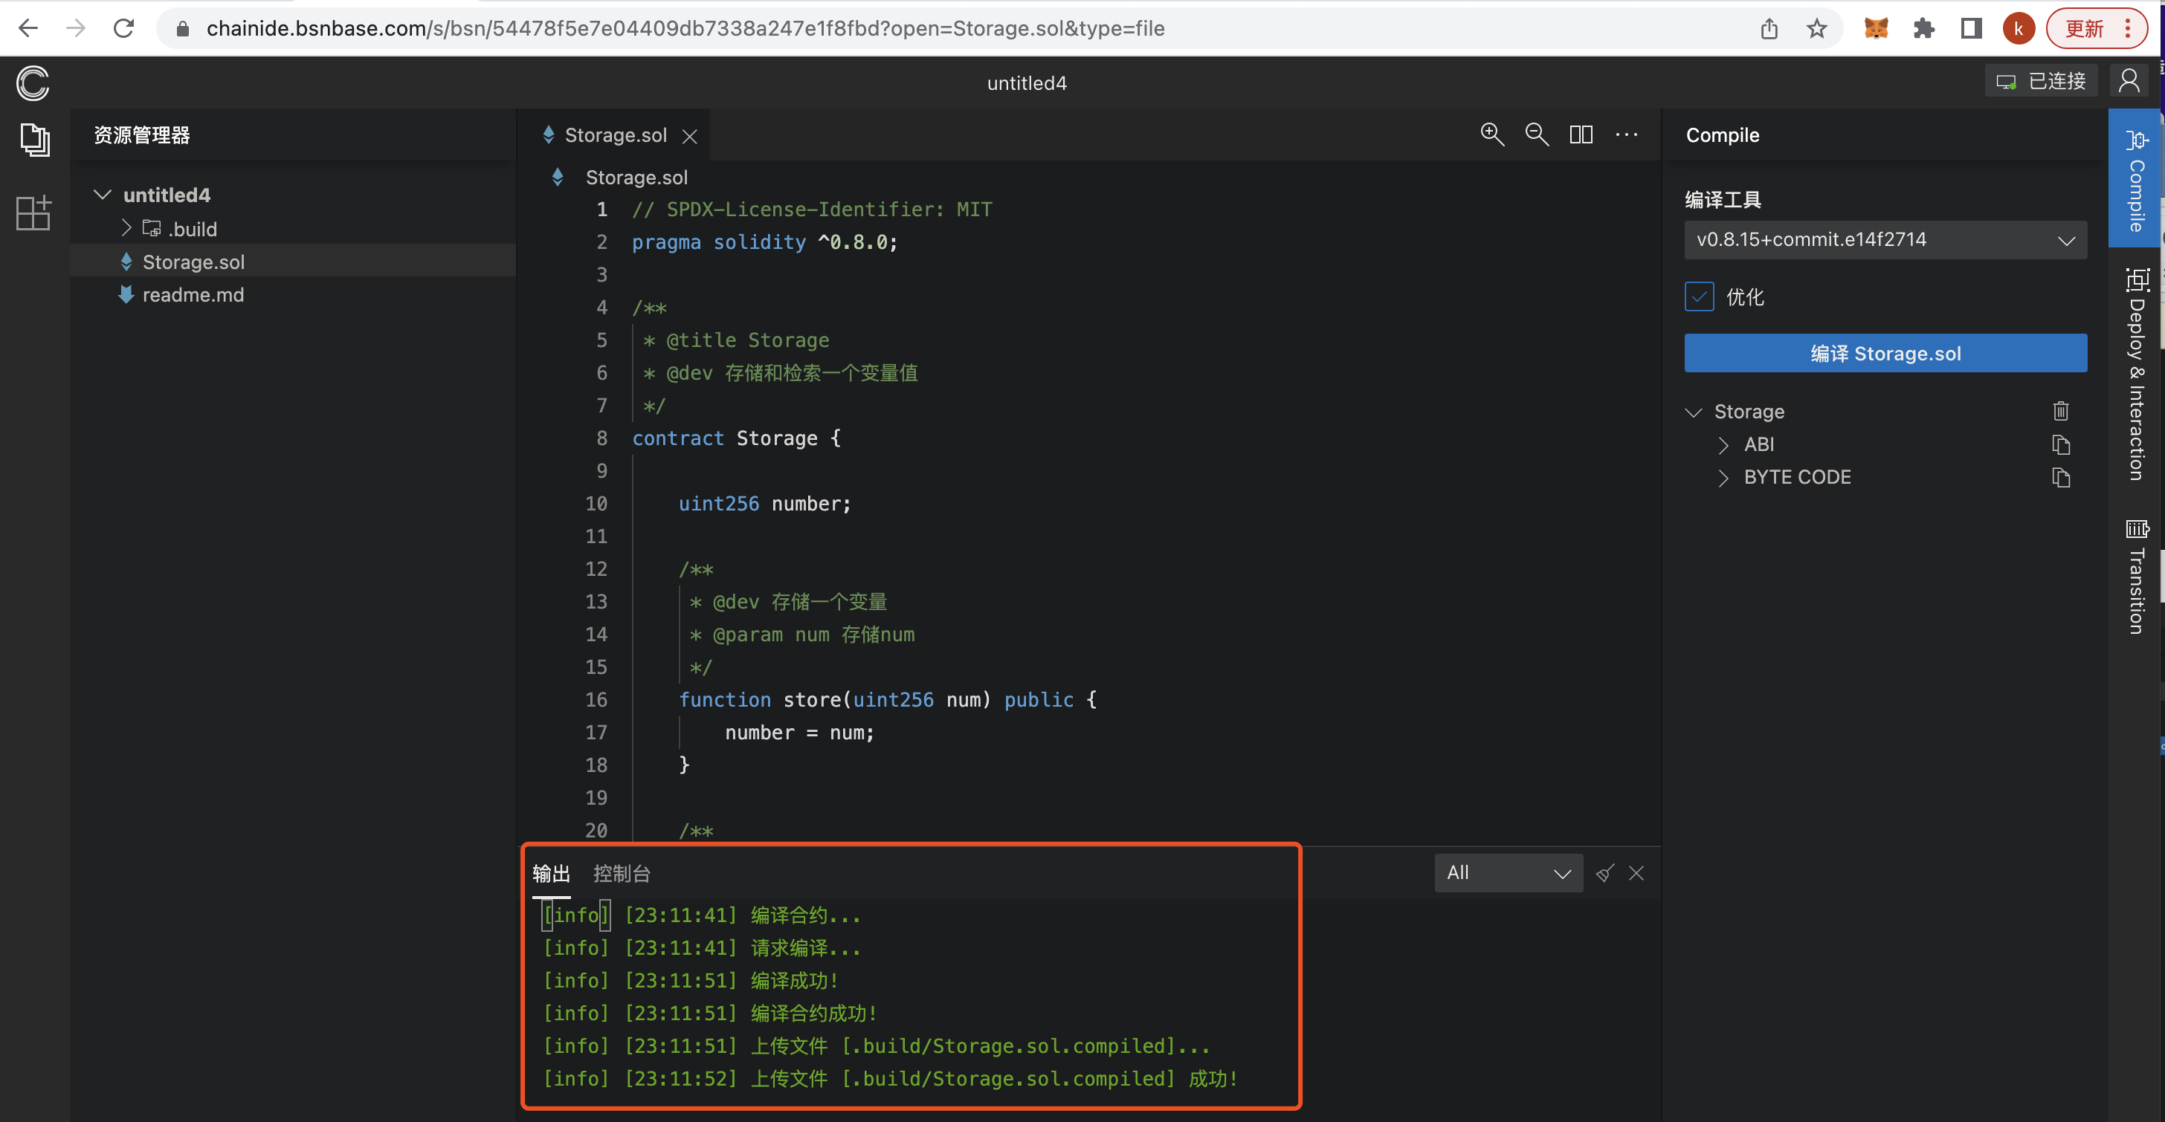

### 2.3.3 Deploying the smart contract

Before deploying the smart contract, you need to connect the plug-in wallet, click the wallet connection button in the upper right corner, and select "Injected Web 3 Provider", then select " MetaMask " and wait patiently for it to connect successfully.

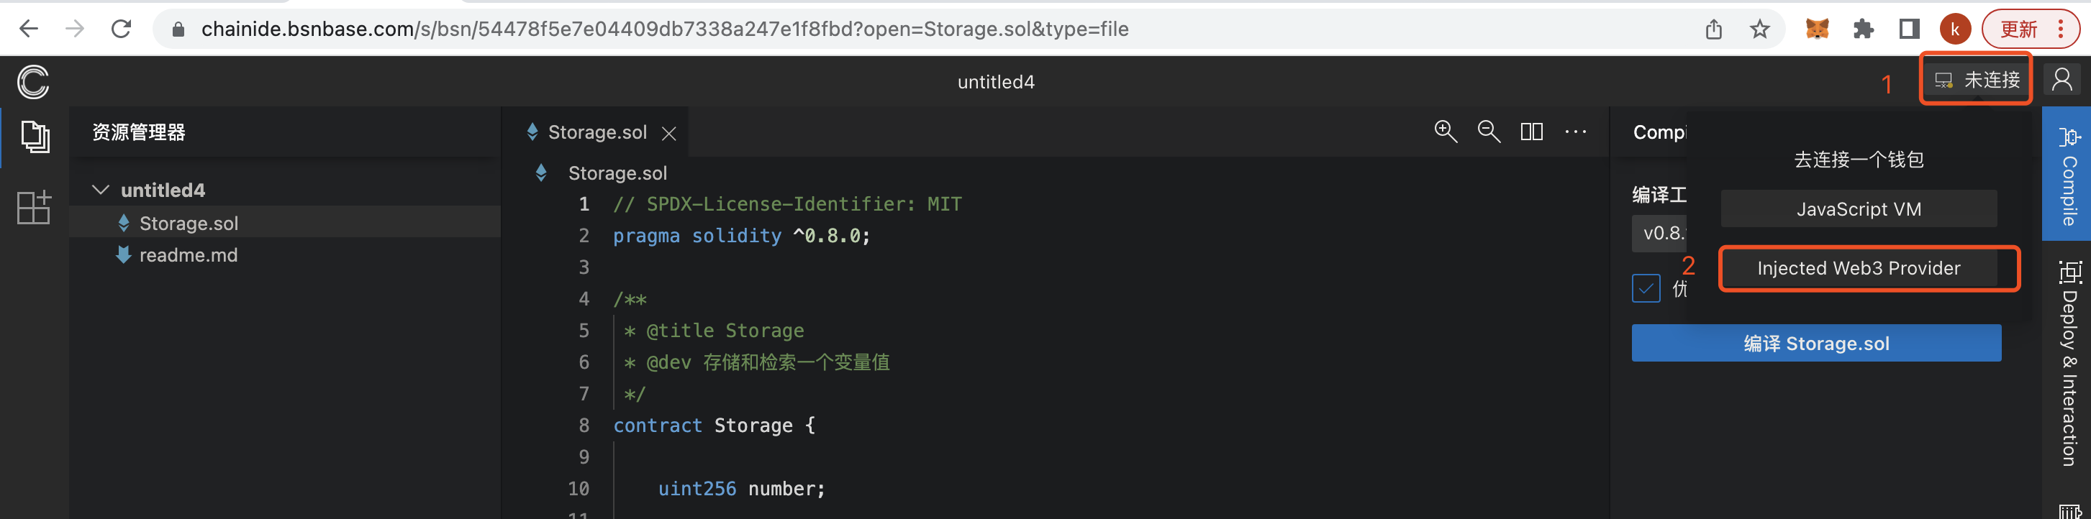

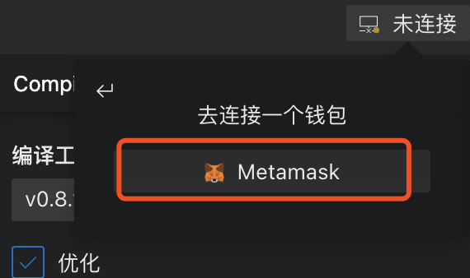

After successfully connecting the MetaMask wallet, click “Deploy & Interaction" on the right sidebar , set the gas price to 1, and then click the "Deploy button". (Note: Before deploying the smart contract, you need to ensure that the BSN account has enough energy value for use.)

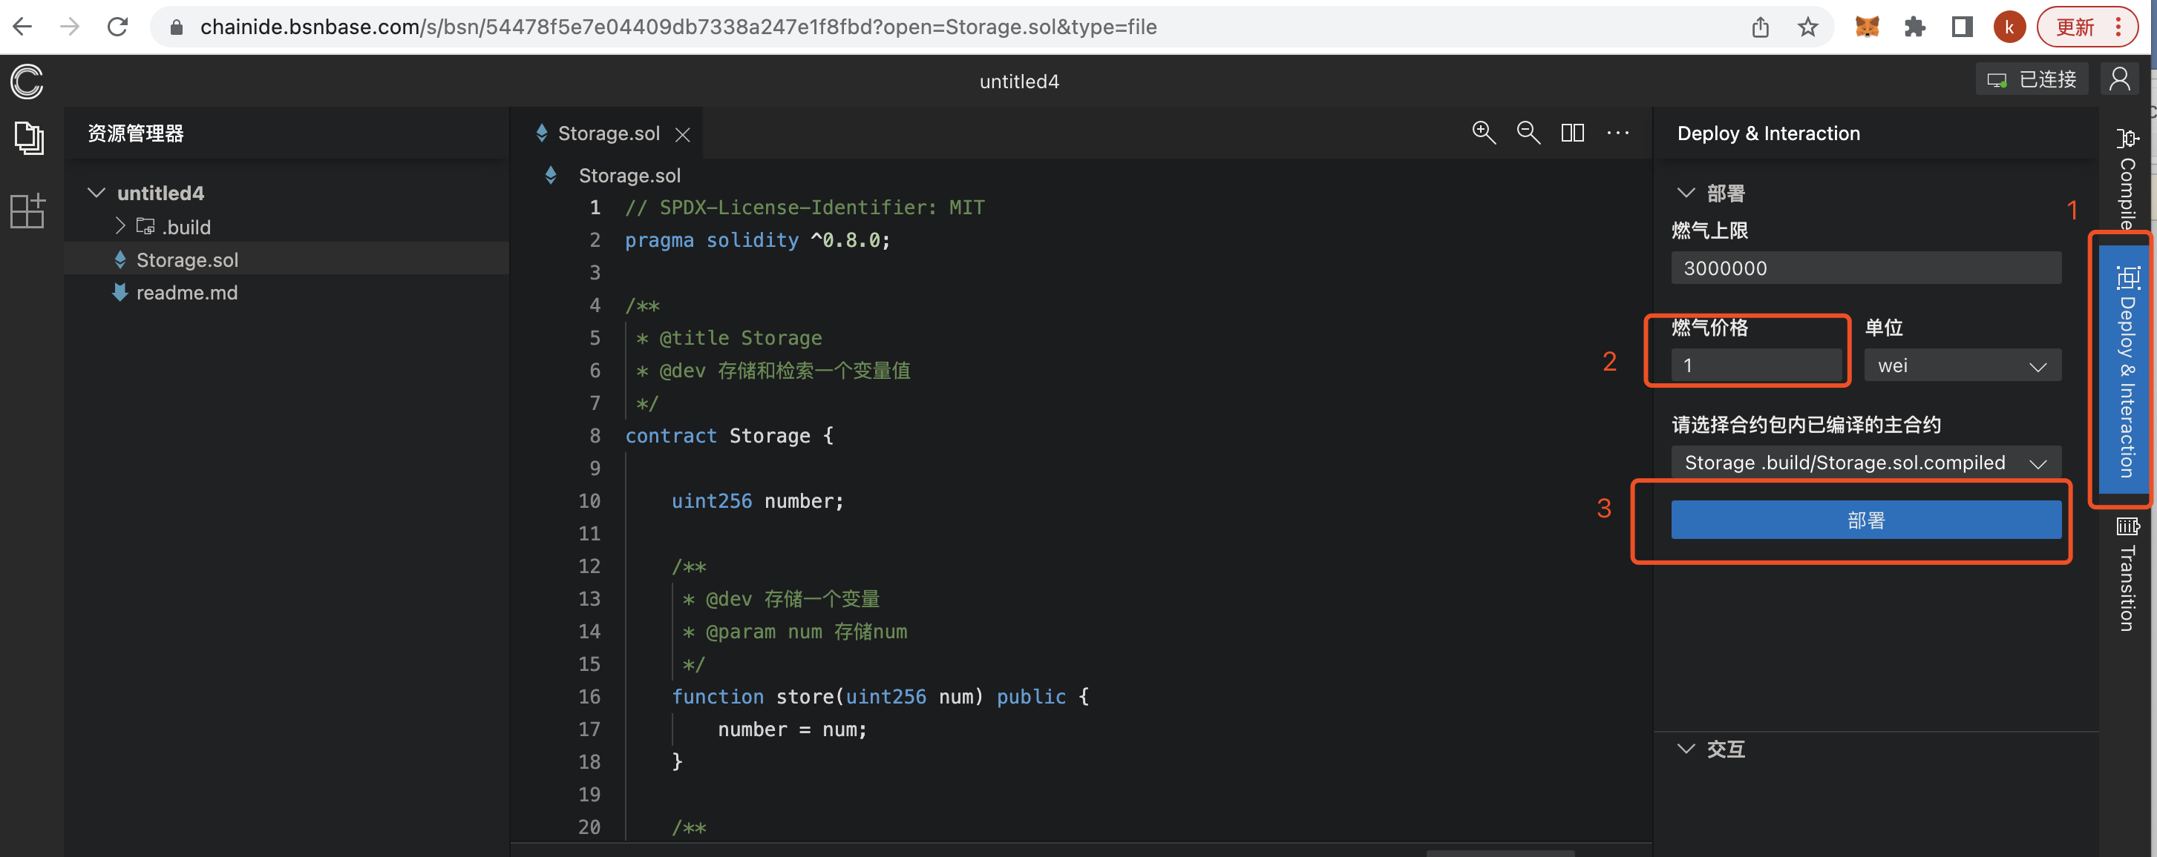

The MetaMask wallet on the top right will receive a signature verification message, select the "confirm" button.

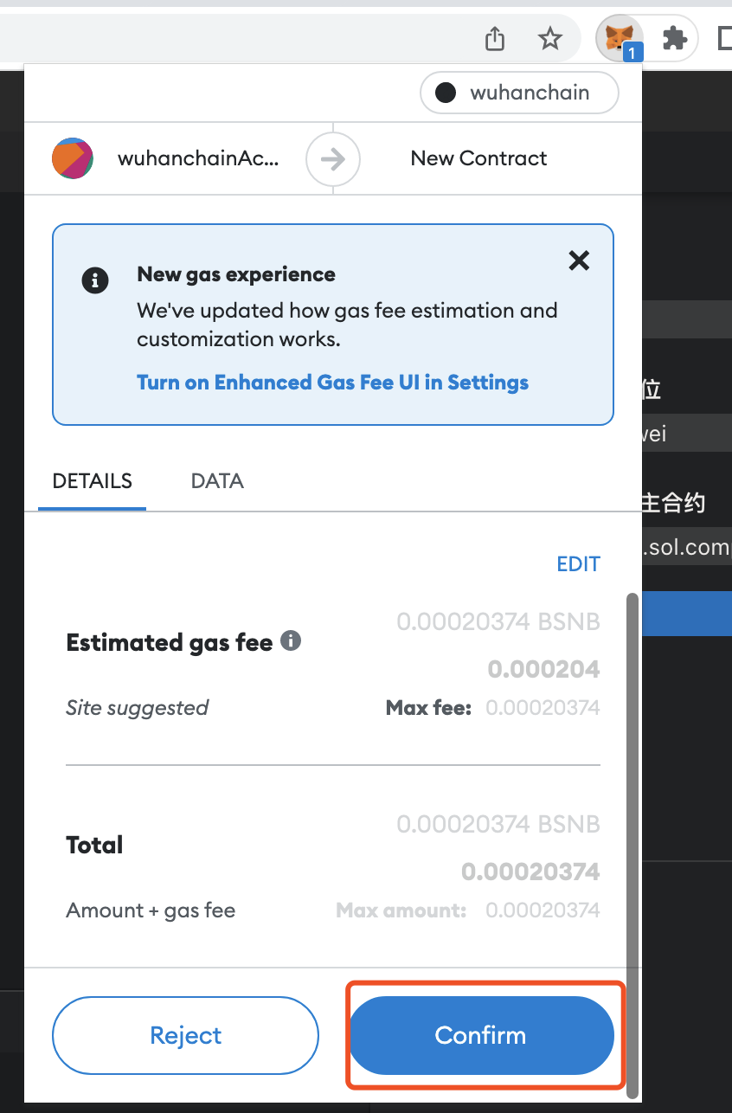

After clicking the "confirm" button, the output terminal at the bottom of the page will continuously output the relevant information about the deployed smart contract. Wuhan Chain currently generates new blocks every ten seconds, so you need to wait patiently for about 10 seconds. The output terminal will display a "Deployment Successful" message if the deployment is successful.

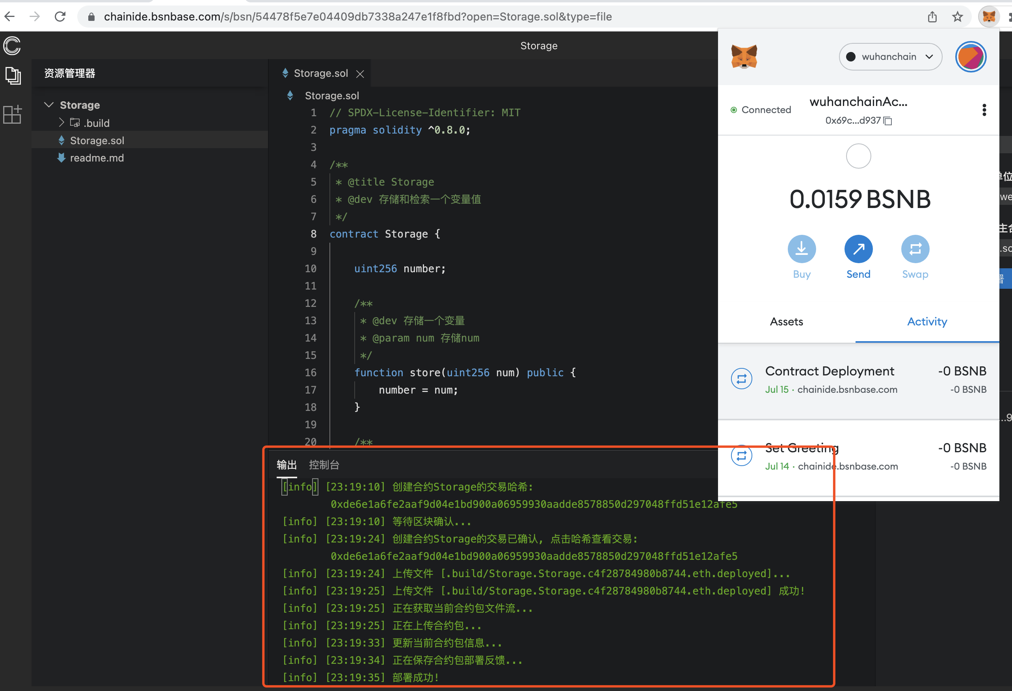

### 2.3.4 Calling the contract interface

After successfully deploying the contract, you can click the interactive component at the bottom right to call the interface test-related functions of the smart contract. (Note: When calling the interface of related operations such as writing, you need to ensure that the account of the BSN project has enough energy value allocated for consumption. Query operations do not consume energy value.)

Select the store interface in the interaction column, fill in a number in the num parameter column, and then click the "call" button. At this time , the MetaMask wallet will receive a signature verification message, and also select the "confirm" button.

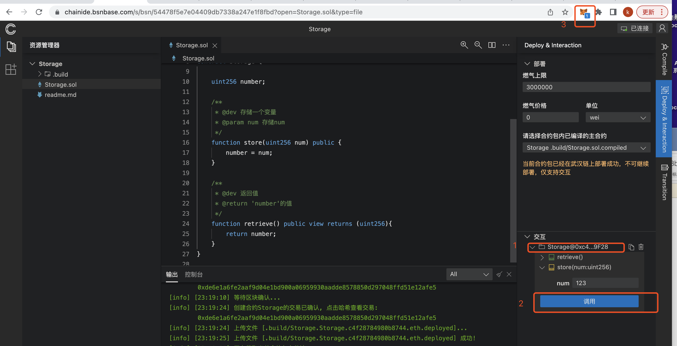

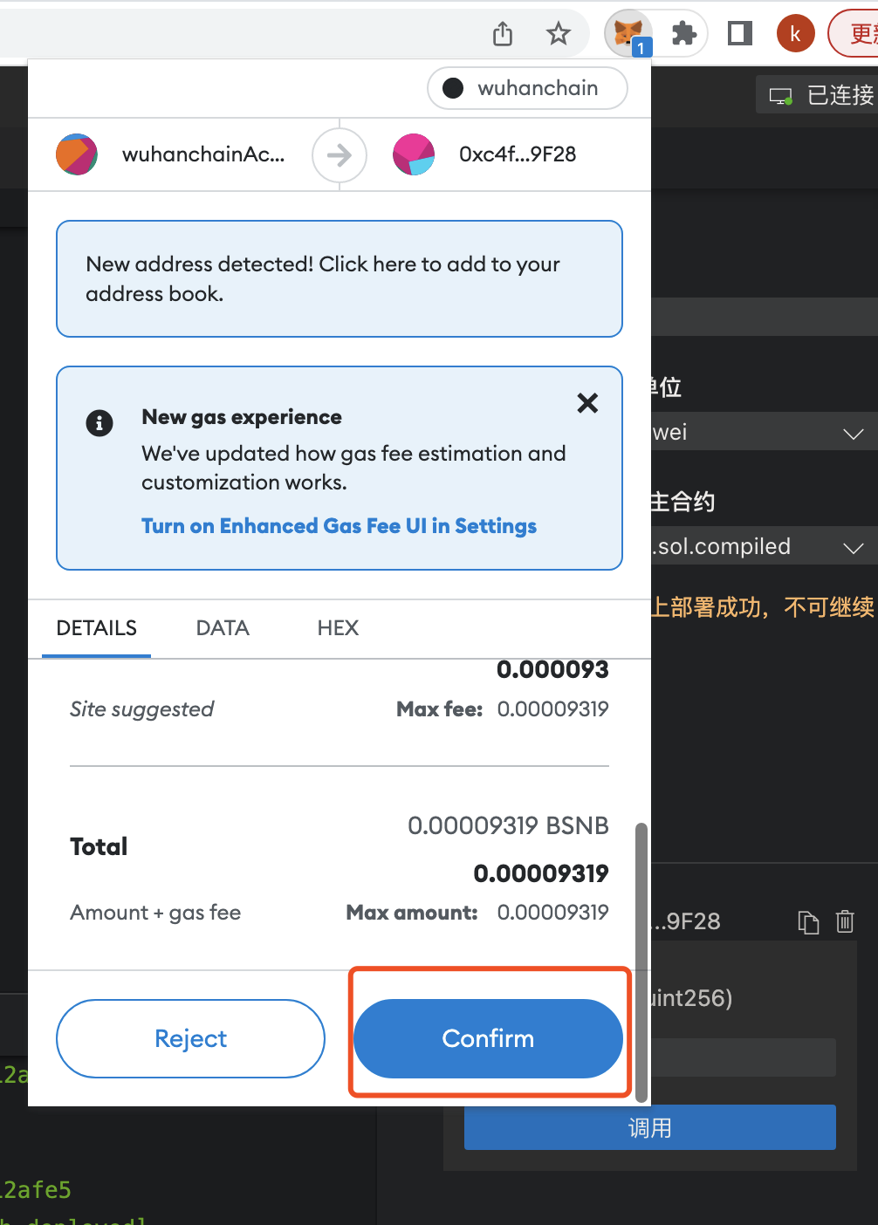

After waiting for about 10 seconds, you can see that the output terminal at the bottom of the page can display the information that the operation of the store transaction has been confirmed.

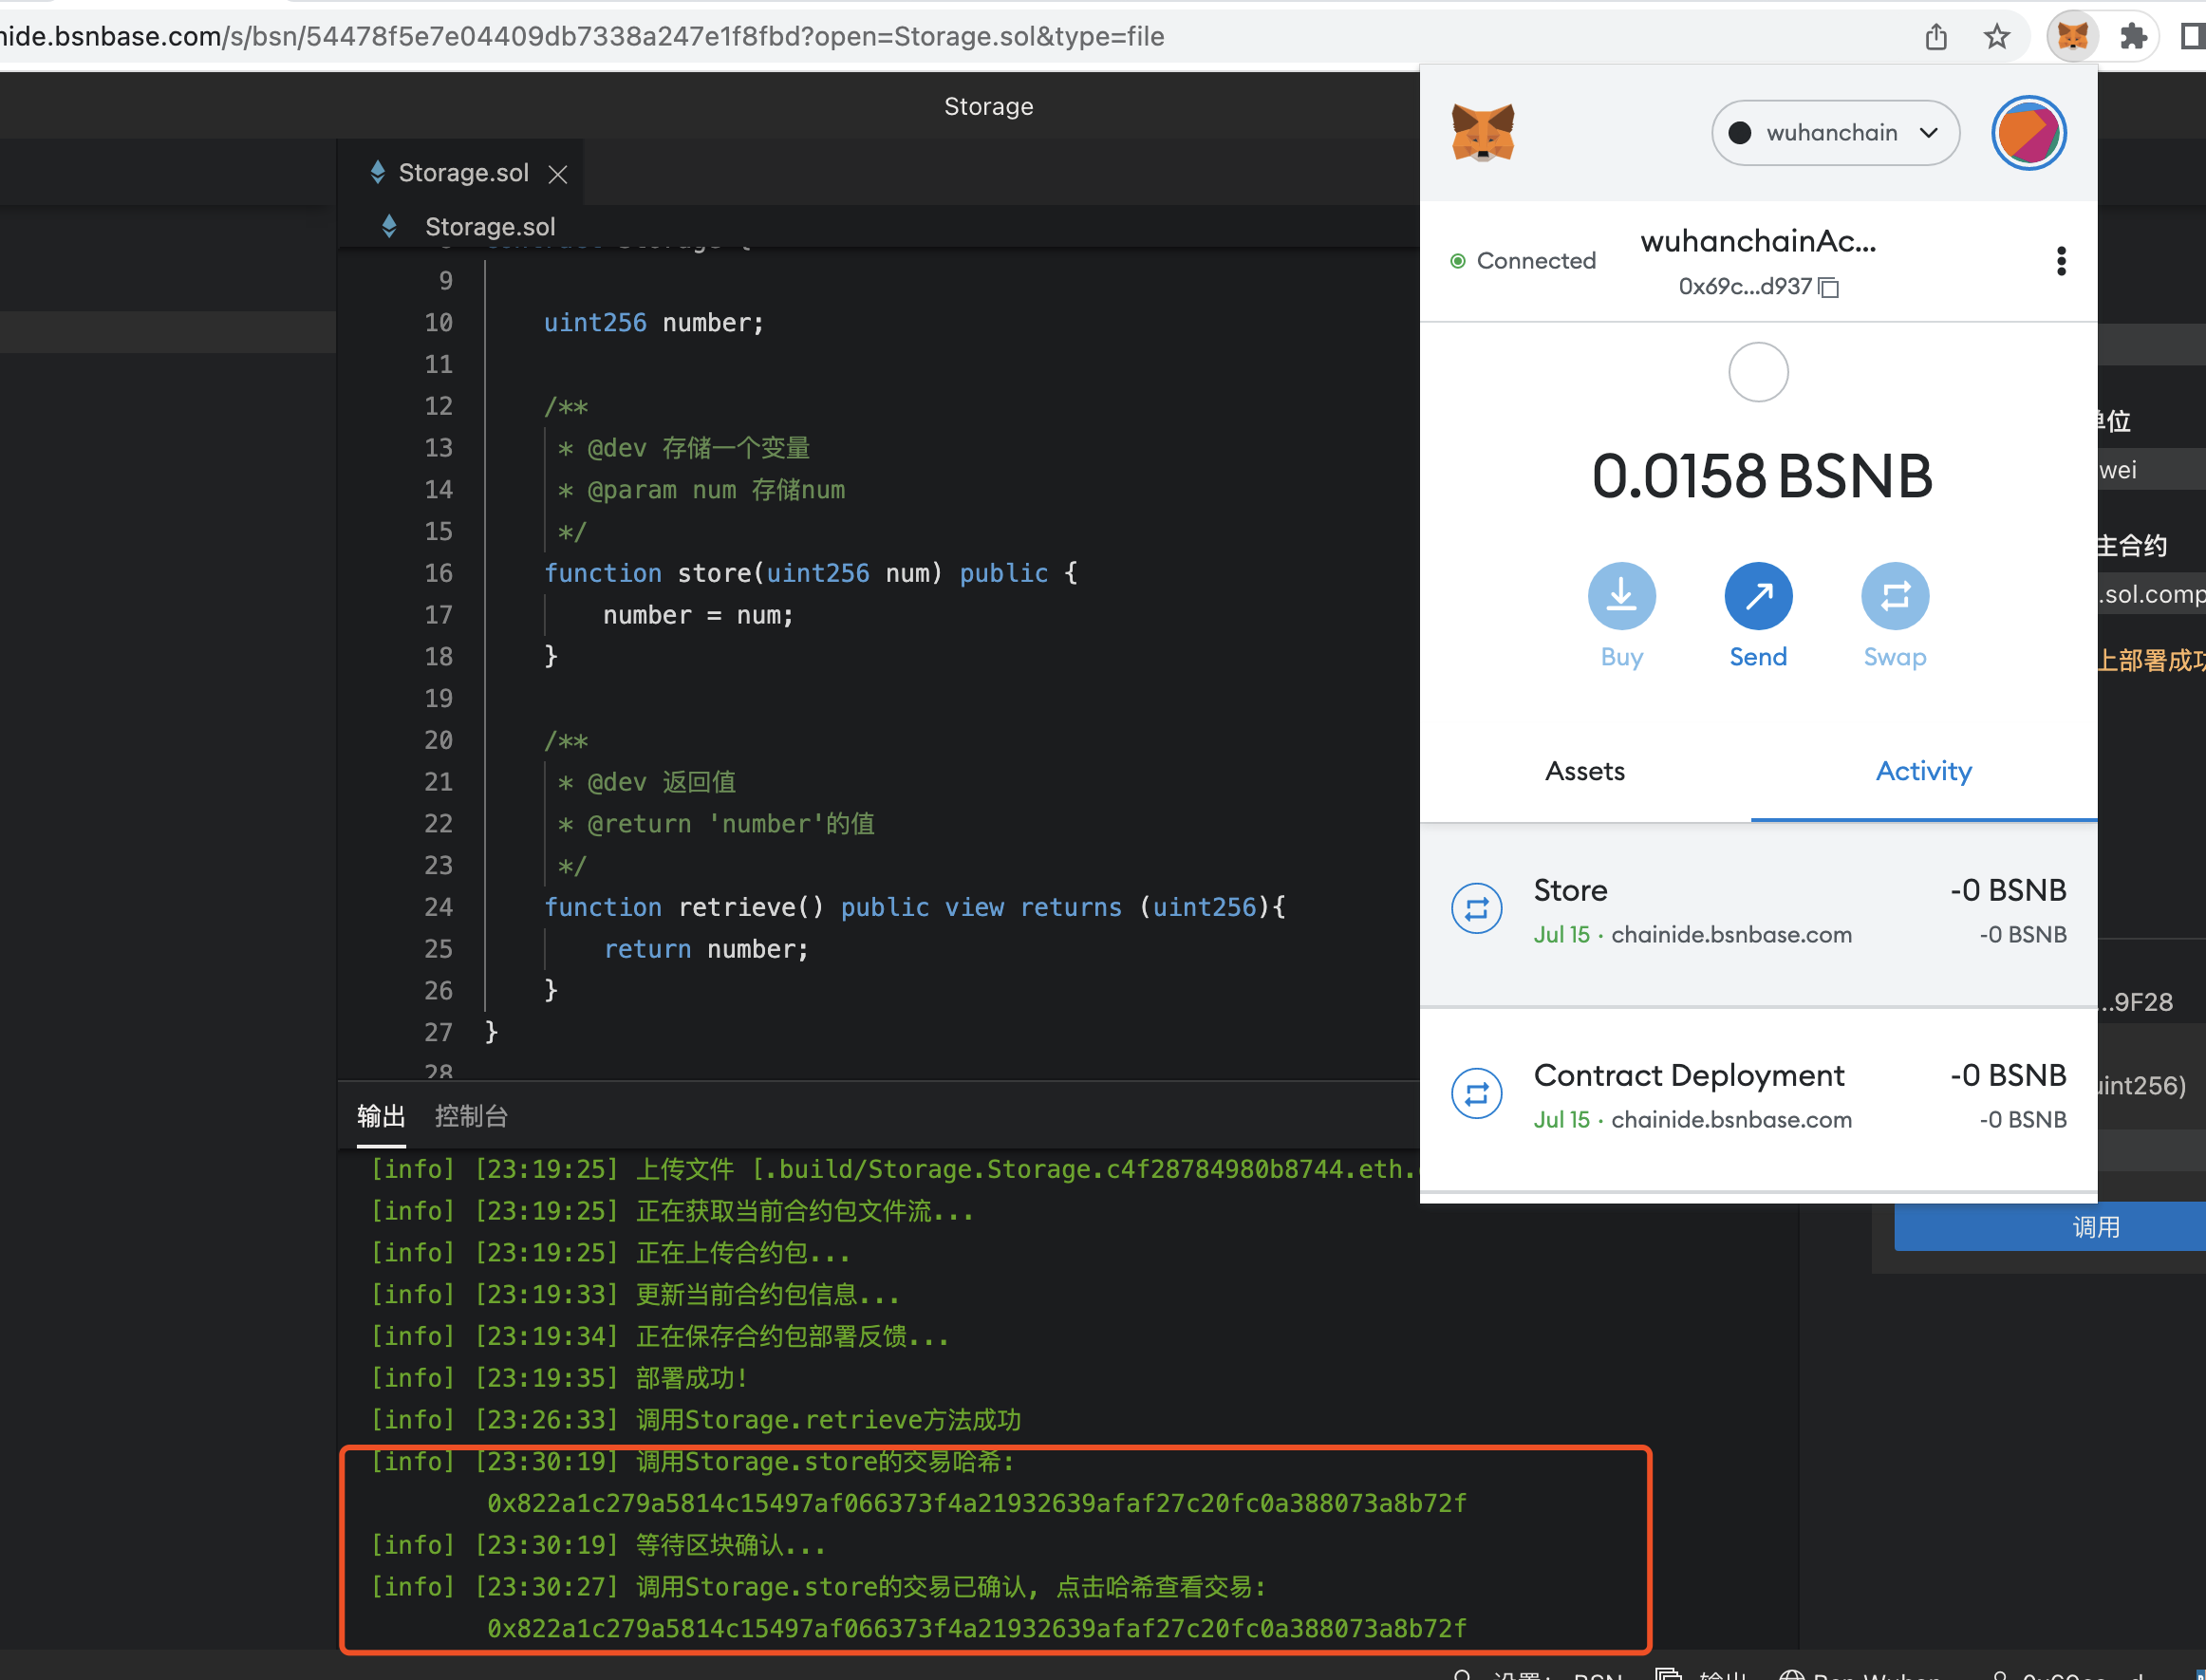

Then select the retrieve interface in the interactive operation bar, click the "Query" button, and you can see that the returned result is the number entered when the store interface was executed just now.

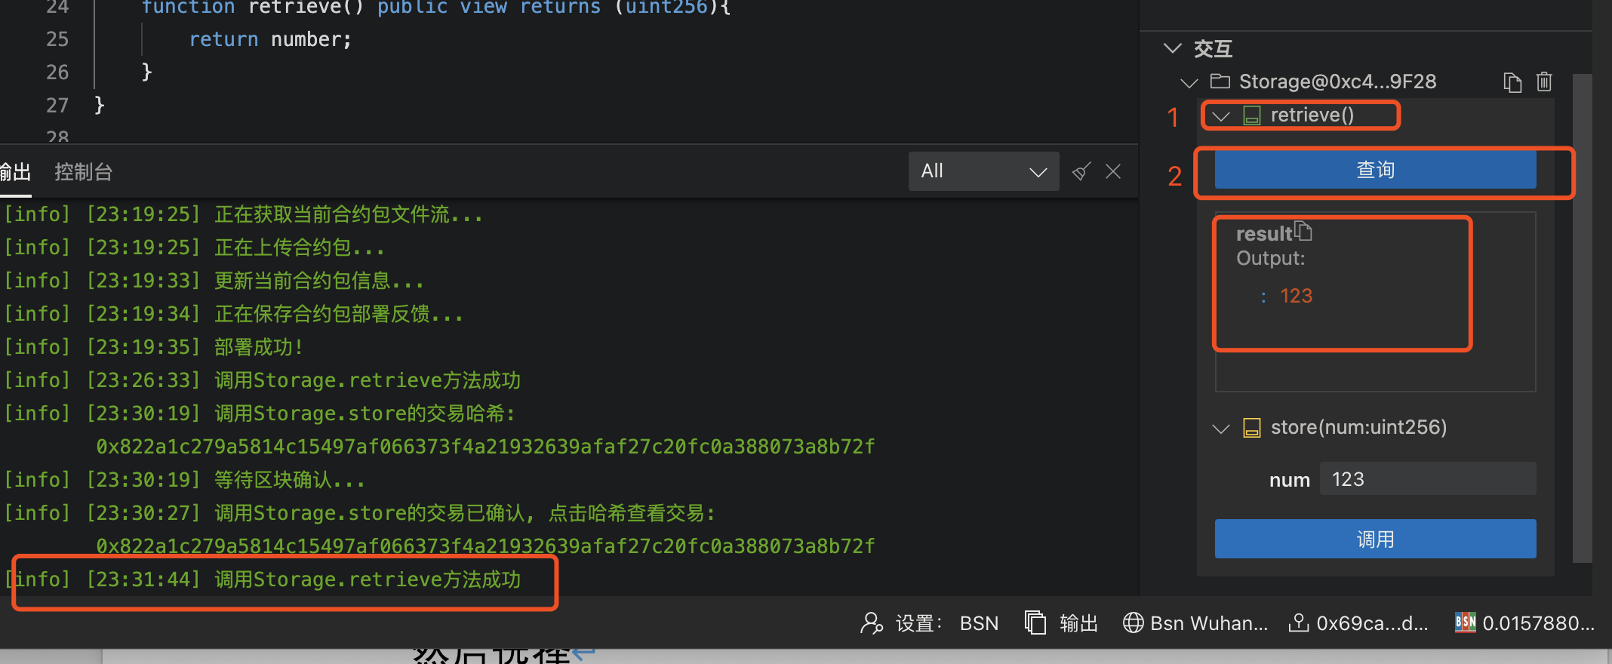

## 2.4 View Wuhan Chain Blockchain Browser

Copy the transaction ID information of the store interface operation that shows in the output terminal of the page just now.

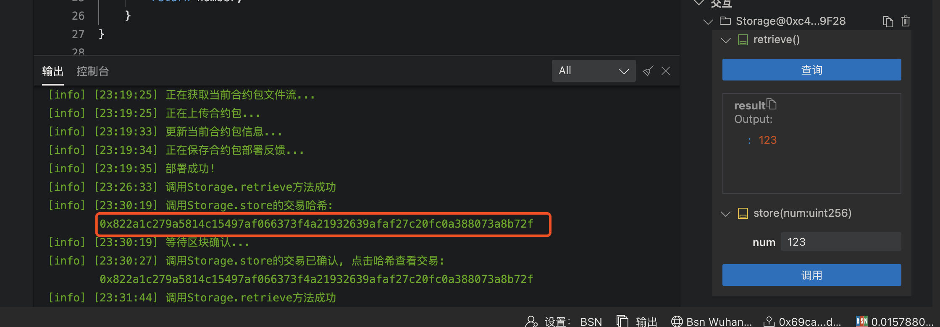

Click “WuHanChain Explorer " on the DEMO page to enter the Wuhan Chain blockchain browser.

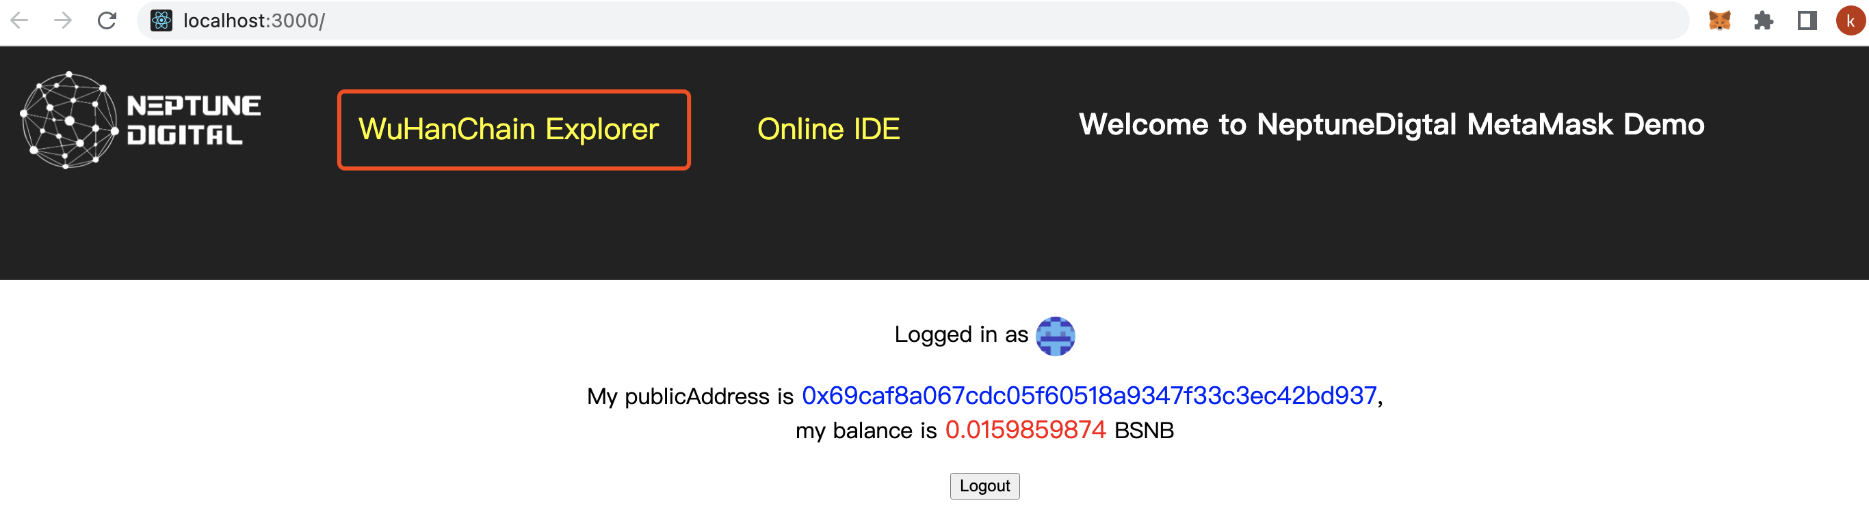

Then paste the transaction ID information just now in the search bar of the Wuhan Chain blockchain browser, and press Enter.  
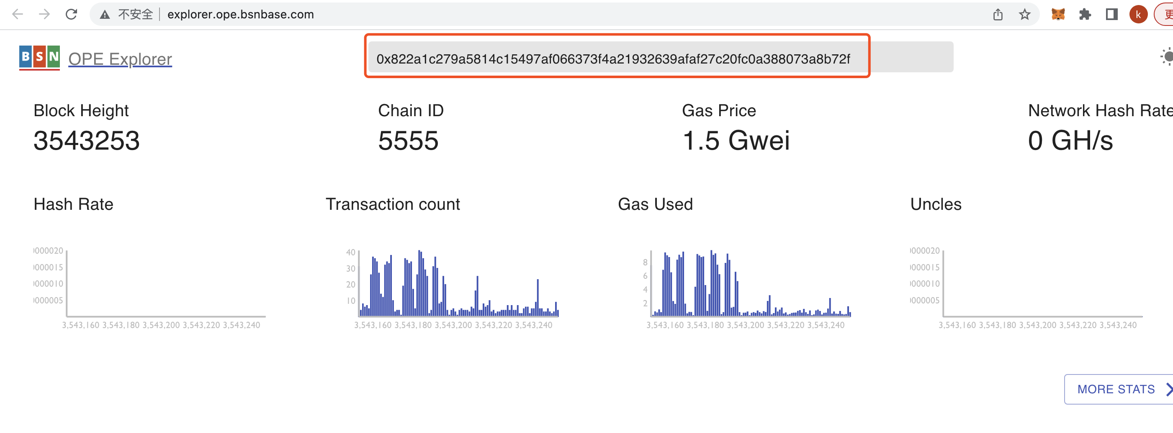

You can see that the page will display the details of this transaction.

## 2.5 Test the smart contract function of DEMO

### 2.5.1 Upload and compile the contract

Firstly upload the compressed file containing the zip of the smart contract file (* .sol ), click 'choose file' button, and select the file to upload. Note: the zip file name must be consistent with the smart contract file name and smart contract class name.

After selecting the compressed file, click the "Upload" button. After prompting that the file is uploaded successfully, click the 'Compile' button to compile the smart contract file.

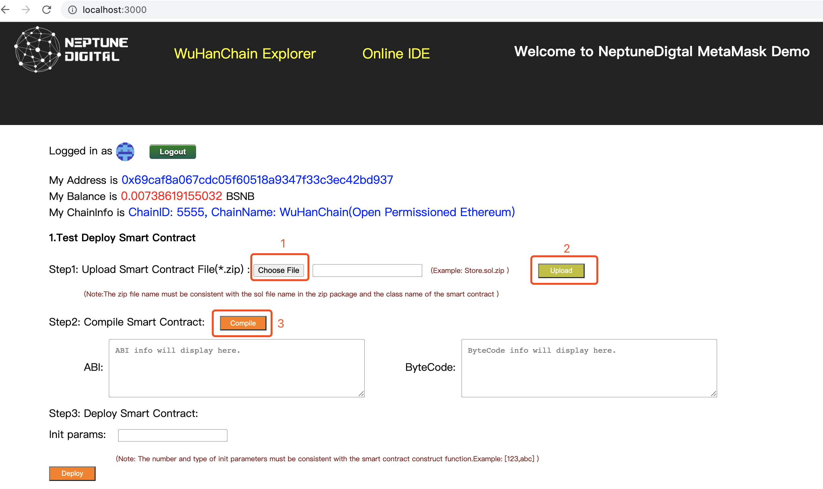

### 2.5.2 Deploy the contract

After the compilation is successful, the details of ABI and ByteCode will be displayed on the page, as well as the list of initialization parameters of the constructor function of the smart contract and the names of all functions that can be called.

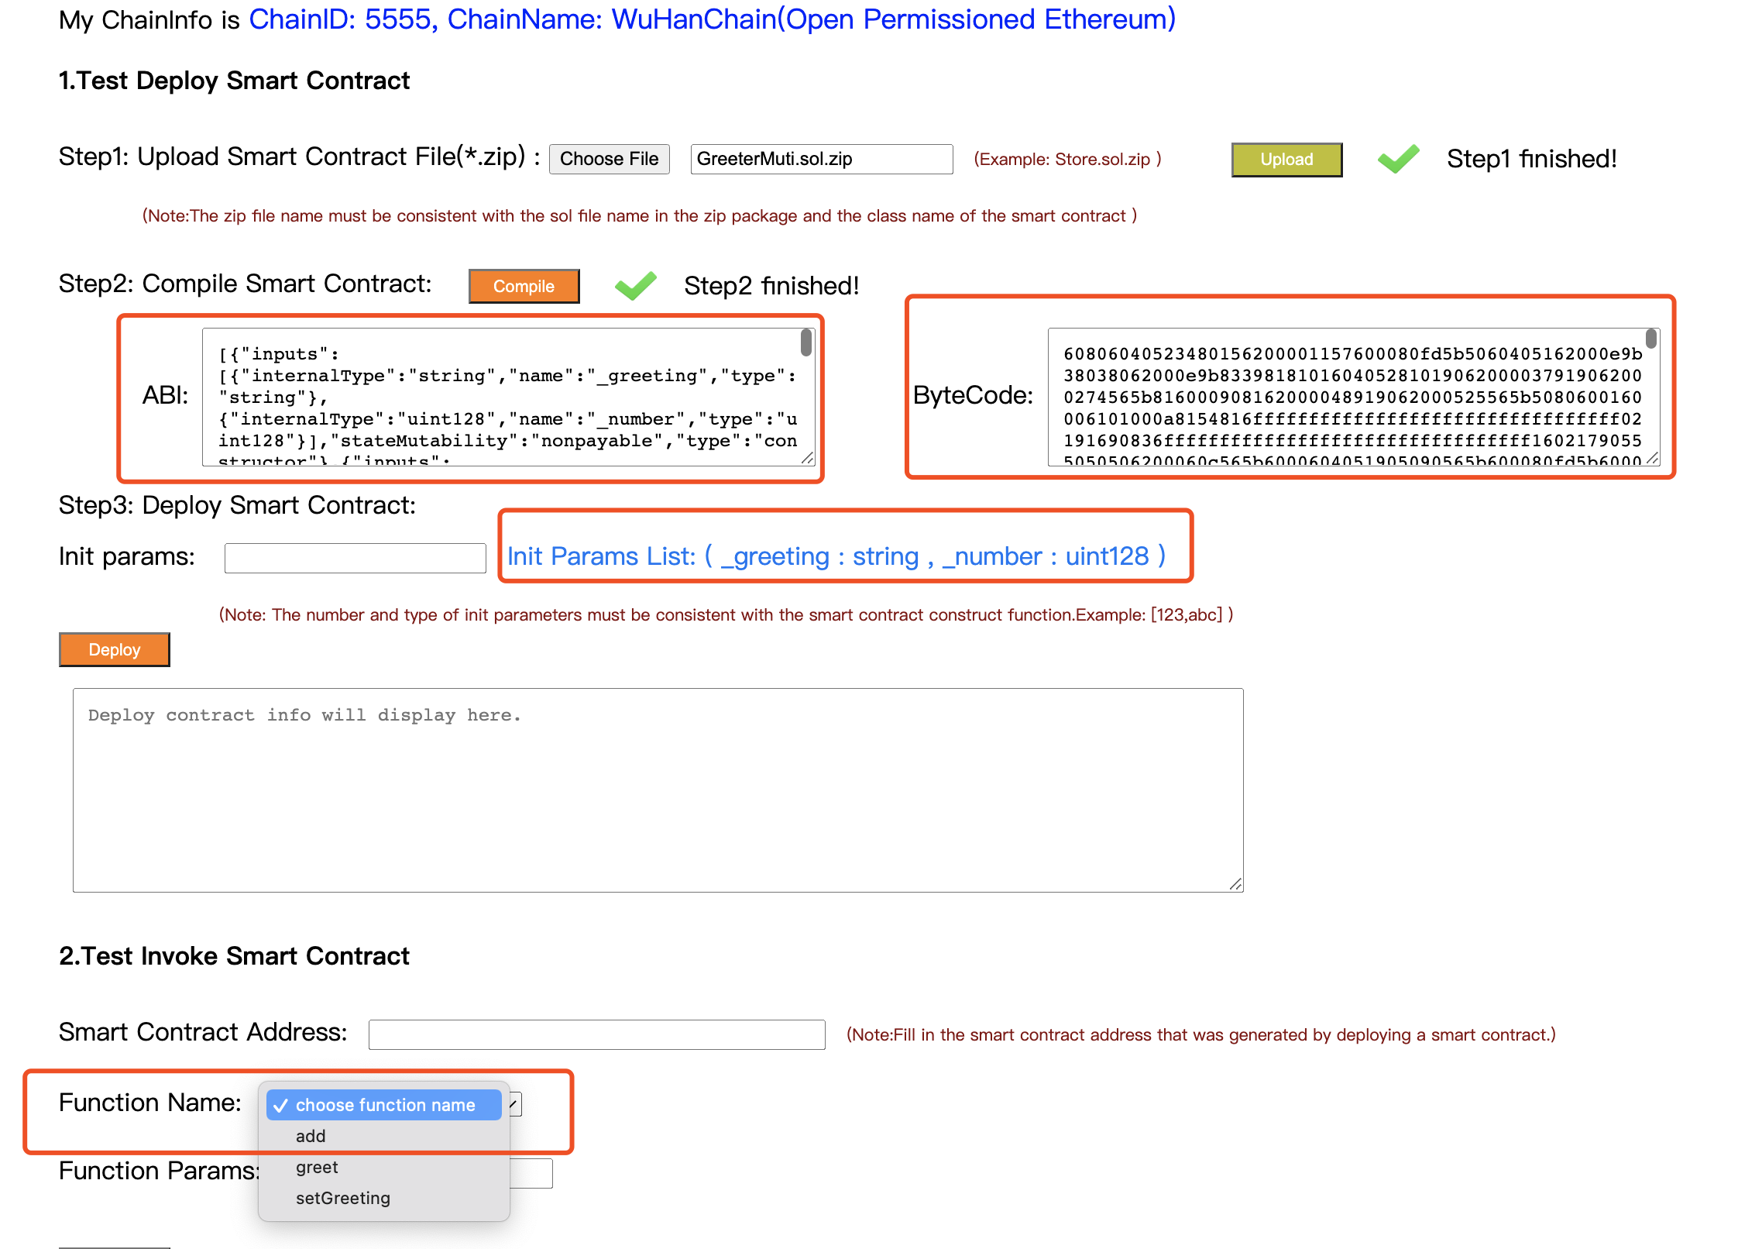

Fill in the 'Init params' input box according to the initialization parameter list of the constructor of the smart contract, then click the "Deploy" button. When deploying the smart contract , you need to connect the browser's MetaMask plugin. After choosing to agree to the authorization, it will start deploying the smart contract. After about ten seconds, you can see the details of the deployment transaction, such as transaction ID and contract address, in the prompt box below. If the deployment of the smart contract is successful, the page will automatically fill in the address of the smart contract to 'Smart Contract Address' input box.

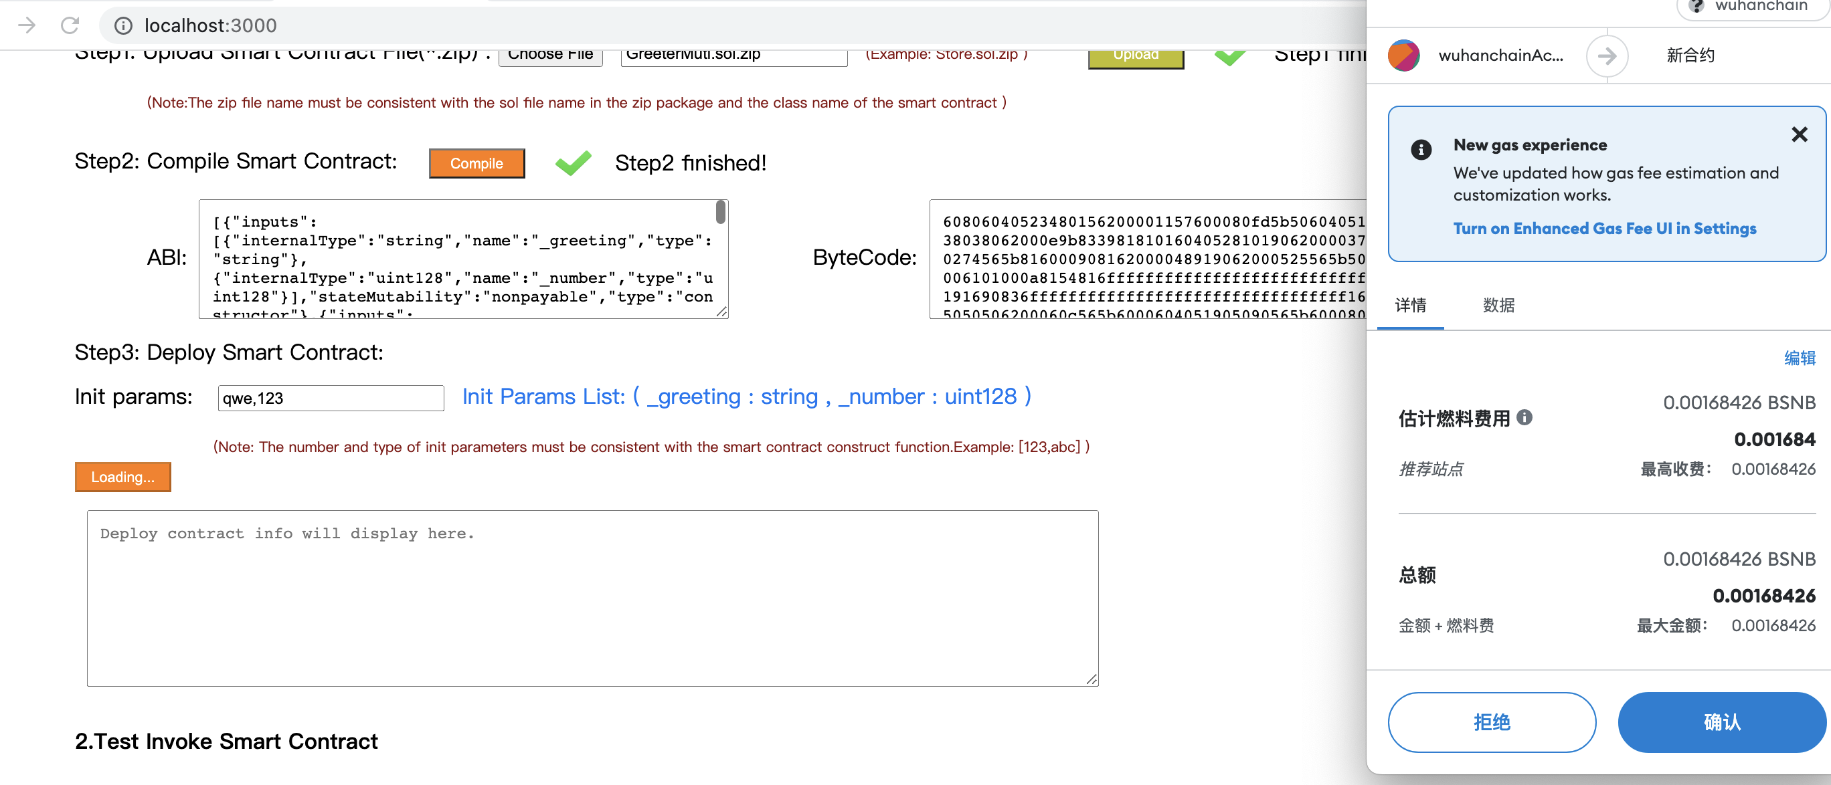

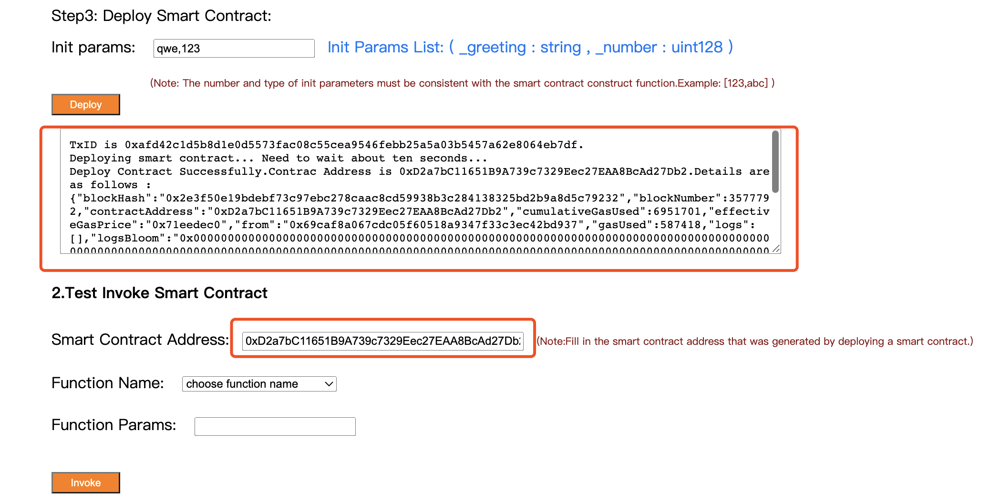

### 2.5.3 Call the contract

Select the function you want to call in the “Function name” drop-down box, and fill in the parameters in the "Function params" input box according to the number and type of the parameter list next to it. If the function does not require parameters, do not fill in. Note: There are two situations when calling a contract function. One is the query function, which does not consume energy value,the other is the invoke fuction, which needs to consume energy value. After filling in the parameters, click the 'query' or 'invoke ' button below. The corresponding return result and calling situation will appear in the prompt box below.

